**Assignment No.1:**

**Write an ASP.Net Program to Demonstrate Use of HTML Controls.**

**Step1:**

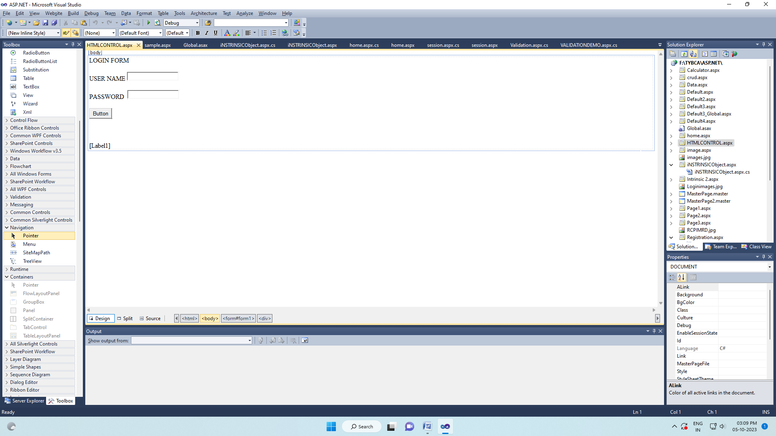  
**Button Coding:**

if (Text1.Value == "abc" && Text2.Value == "1234")

{

Label1.Text = "login successfull";

}

else

{

Label1.Text = "user name and password incorrect";

}

**Output:**

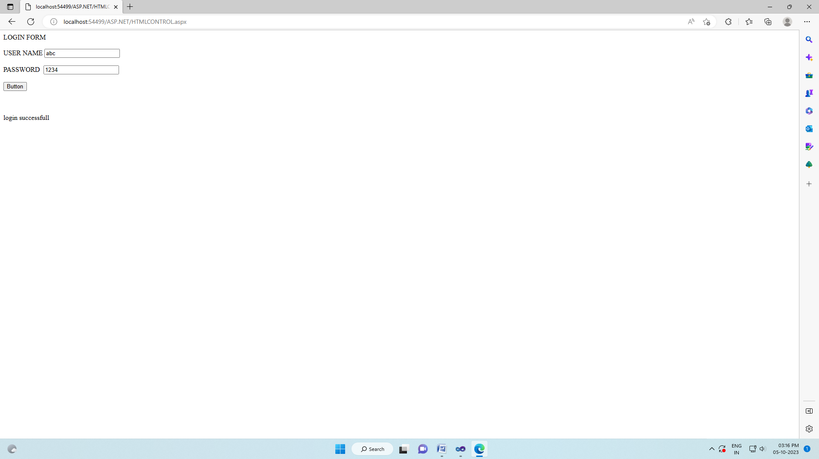

**Assignment No.2:**

**Write an ASP.Net Program to Demonstrate Use of Web Controls.**

**Default.aspx**

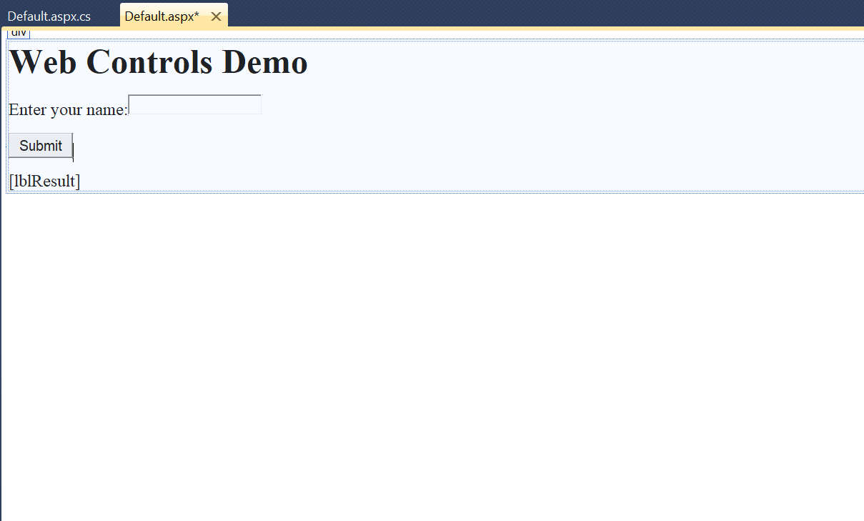

**Default.aspx.cs**

using System;

using System.Collections.Generic;

using System.Linq;

using System.Web;

using System.Web.UI;

using System.Web.UI.WebControls;

public partial class _Default : System.Web.UI.Page

{

protected void Page_Load(object sender, EventArgs e)

{

}

protected void btnSubmit_Click(object sender, EventArgs e)

{

string userName = txtName.Text;

lblResult.Text = "Hello, " + userName + "! You clicked the Submit button.";

}

}

**Output:**

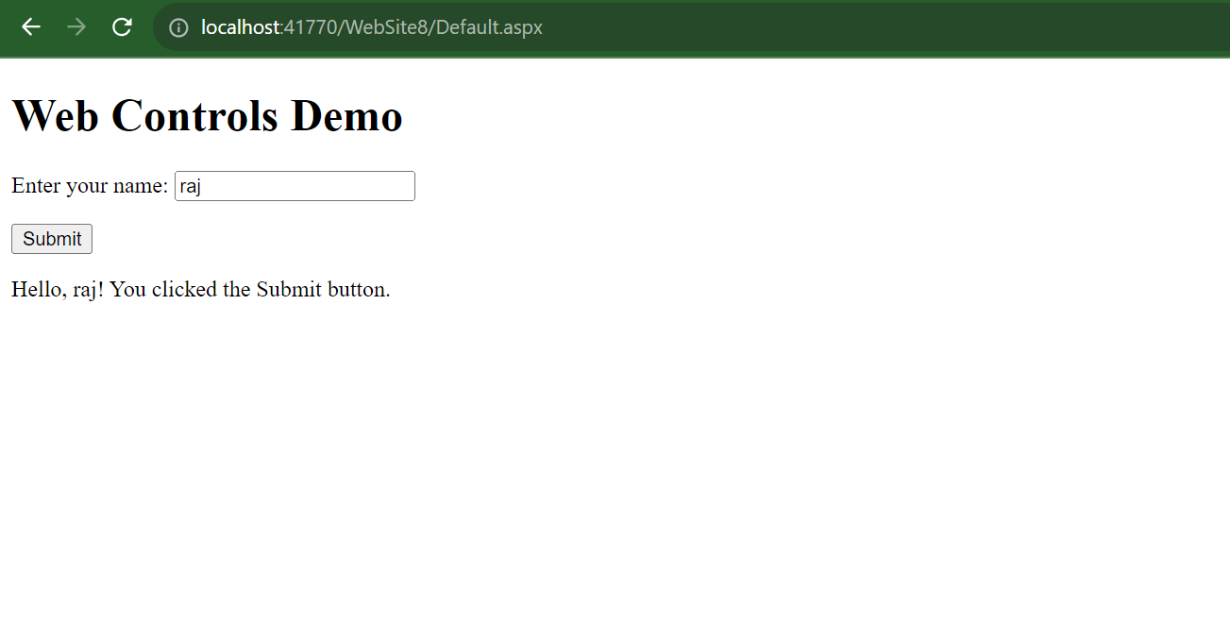

**Assignment No.3:**

**Write an ASP.Net Program to Returns The Windows Name of Your Computer And URL of the Page That You are Visiting.**

**Default.aspx**

<%@ Page Language="C#" AutoEventWireup="true" CodeFile="Default.aspx.cs" Inherits="_Default" %>

<!DOCTYPE html PUBLIC "-//W3C//DTD XHTML 1.0 Transitional//EN" "http://www.w3.org/TR/xhtml1/DTD/xhtml1-transitional.dtd">

<html xmlns="http://www.w3.org/1999/xhtml">

<head id="Head1" runat="server">

<title>Computer Name and URL</title>

</head>

<body>

<form id="form1" runat="server">

<div>

<h1>Computer Name and URL</h1>

<p>Computer Name: <%= System.Environment.MachineName %></p>

<p>Current Page URL: <%= Request.Url.AbsoluteUri %></p>

</div>

</form>

</body>

</html>

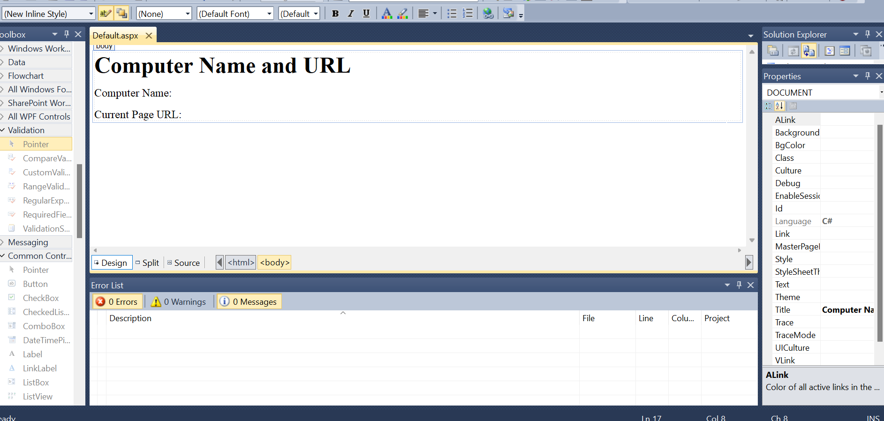

**Output:**

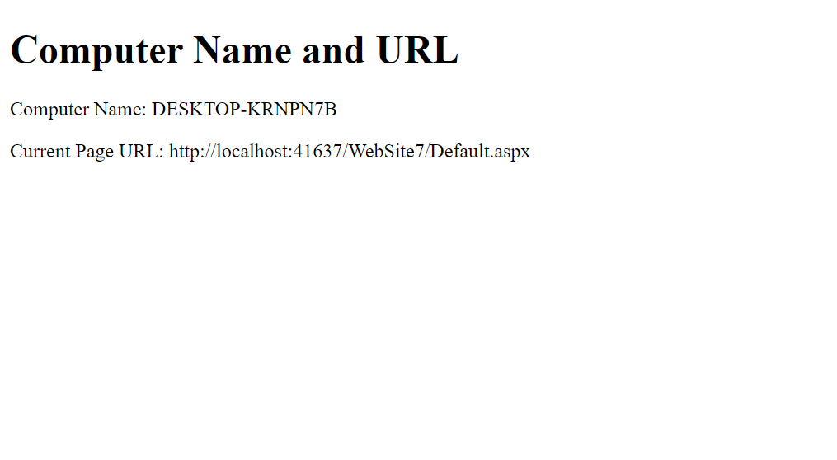

**Assignment No.4:**

Write an ASP.NET program to demonstrate use of Validation Controls

# Step 1:- Open Visual Studio 2010.

Step 2:-Create new webform (Student Information Form Show in SC).

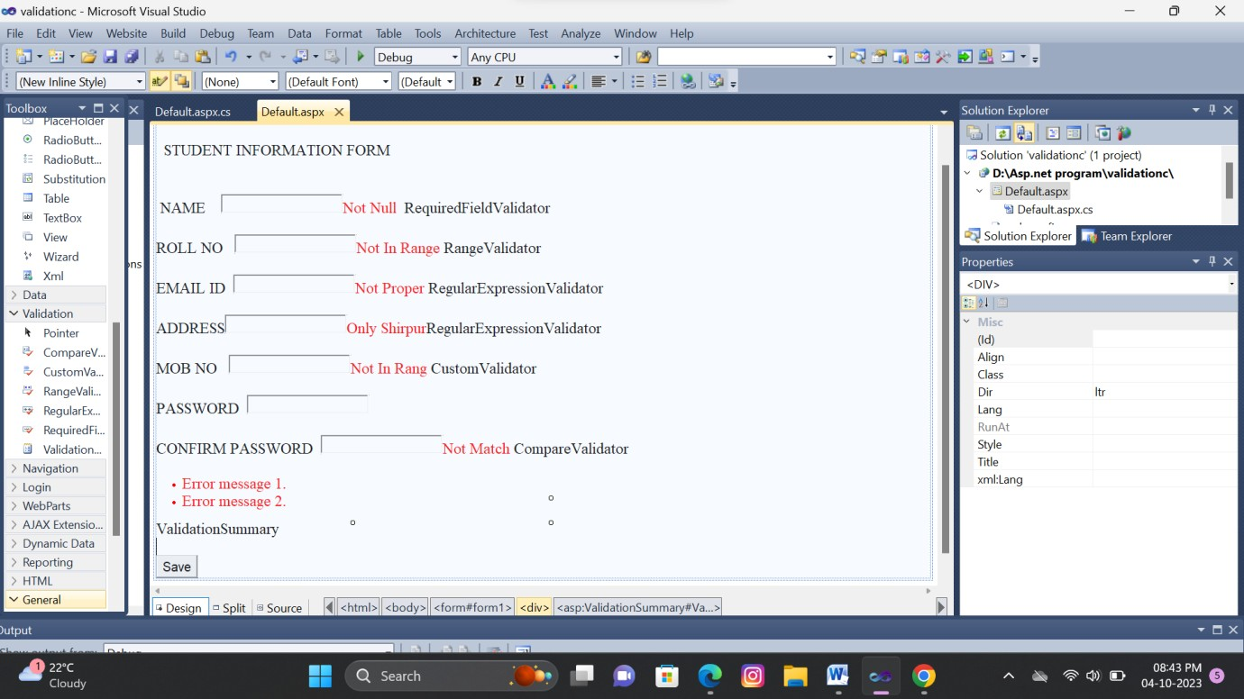

# Step 3:-Go to View>ToolBox>Show the different Validation Controls.

* Different types of Validation Controls:-

1. RequiredFieldValidator.
2. RangeValidator
3. CompareValidator
4. RegularExpressionValidator
5. CustomValidator
6. ValidationSummary
7. **RequiredFieldValidator :-**The RequiredFieldValidator control ensures that the required field is not empty. It is generally tied to a text box to force input into the text box.

## Properties:-

**ControlToValidate:** Indicates the input control to validate.

**ErrorMessage:-** Indicates error string.

**Text:-** Error text to be shown if validation fails.

**ForeColor:-**It is error message text color.

Step 4:- Then Paste the RequiredFieldValidator in side of NAME text box .Click on validation control then set the properties of validation. (show in below sc)

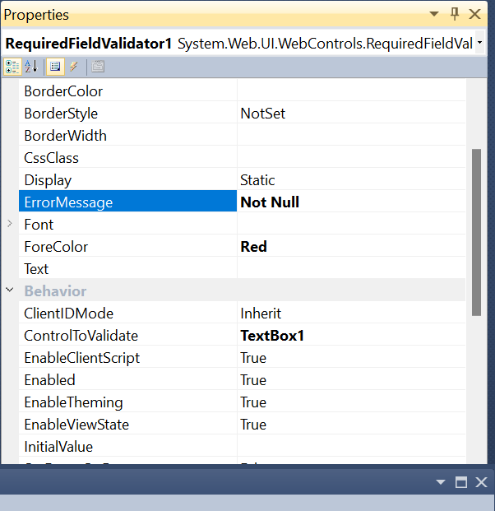

1. **RangeValidator:-** The RangeValidator control verifies that the input value falls within a predetermined range.

## Properties:-

**ControlToValidate:** Indicates the input control to validate.

**ErrorMessage:-** Indicates error string.

|  |  |
| --- | --- |
| **MinimumValue:-** | It specifies the minimum value of the range. |

|  |  |
| --- | --- |
| **MaximumValue:-** | It specifies the maximum value of the range. |

Step 5:- Then Paste the RangeValidator in side of EMAIL-ID text box .Click on validation control > set the properties of validation. (show in below sc)

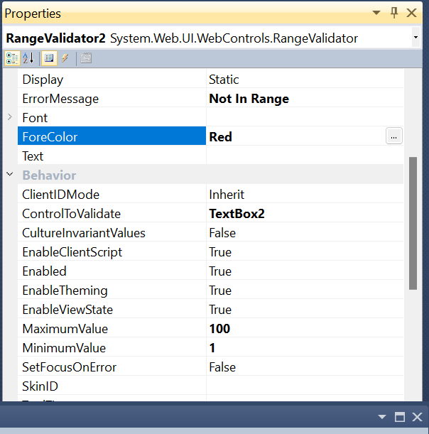

1. **RegularExpressionValidator:-** The RegularExpressionValidator allows validating the input text by matching against a pattern of a regular expression. The regular expression is set in the ValidationExpression property.

## Properties:-

**ControlToValidate:** Indicates the input control to validate.

**ErrorMessage:-** Indicates error string.

**ValidationExpression:-** It set different types the validation.

Step 5:- Then Paste the RegularExpressionValidator in side of ROLL NO text box .Click on validation control > set the properties of validation. (show in below sc)

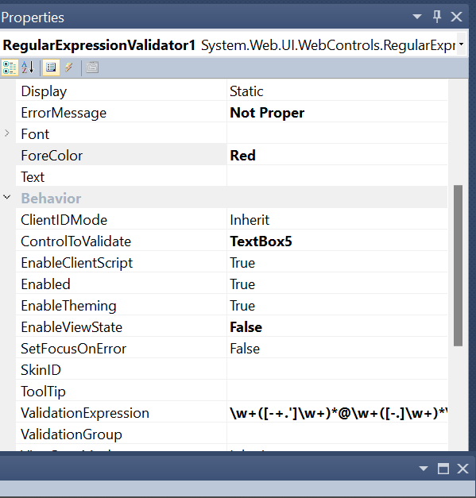

1. **CustomValidator:-** The CustomValidator control allows writing application specific custom validation routines for both the client side and the server side validation.

The client side validation is accomplished through the ClientValidationFunction property. The client side validation routine should be written in a scripting language, such as JavaScript or VBScript, which the browser can understand.

## Properties:-

**ControlToValidate:** Indicates the input control to validate.

**ErrorMessage:-** Indicates error string.

**ClientValidationFuncation:-**To called the client side funcation.

Step 5:- Then Paste the Custom Validator in side of MOB NO text box .Click on validation control > set the properties of validation. Double click on control and write the code for client side validation and called the function on properties.

(show in below sc)

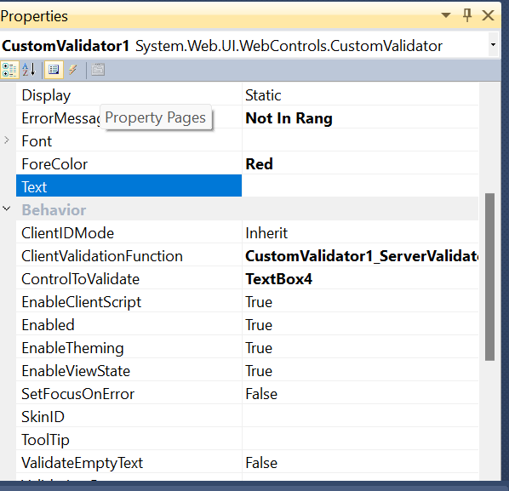

using System;

using System.Collections.Generic; using System.Linq;

using System.Web; using System.Web.UI;

using System.Web.UI.WebControls;

public partial class _Default : System.Web.UI.Page

{

protected void Page_Load(object sender, EventArgs e)

{

}

protected void CustomValidator1_ServerValidate(object source, ServerValidateEventArgs args)

{

}

protected void CustomValidator1_ServerValidate1(object source, ServerValidateEventArgs args)

{

if (args.Value.Length >= 10) args.IsValid = true;

else

}

}

args.IsValid = false;

1. **CompareValidator:-** The CompareValidator control compares a value in one control with a fixed value or a value in another control.

## Properties:-

**ControlToValidate:** Indicates the input control to validate.

**ErrorMessage:-** Indicates error string.:

|  |  |
| --- | --- |
| **ControlToCompare:-** | It specifies the value of the input control to compare with. |
| **ValueToCompare:-** | It specifies the constant value to compare with. |

Step 6:- Then Paste the Compare Validator in side of CONFIRM PASSWORD text box .Click on validation control > set the properties of validation. (show in below sc)

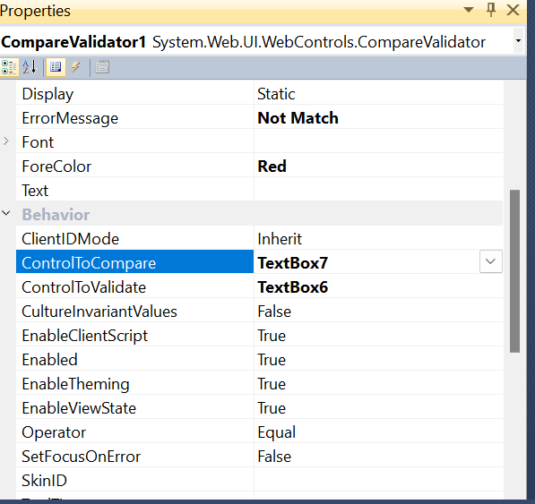

1. **ValidationSummary:-** Complex pages have different groups of information provided in different panels. To create a validation group, you should put the input controls and the validation controls into the same logical group by setting

their *ValidationGroup* property.

## Properties:-

* + **ShowSummary** : shows the error messages in specified format.
  + **ShowMessageBox** : shows the error messages in a separate window.

**OUTPUT:**

If type incorrect information the output is show error.(Validations)

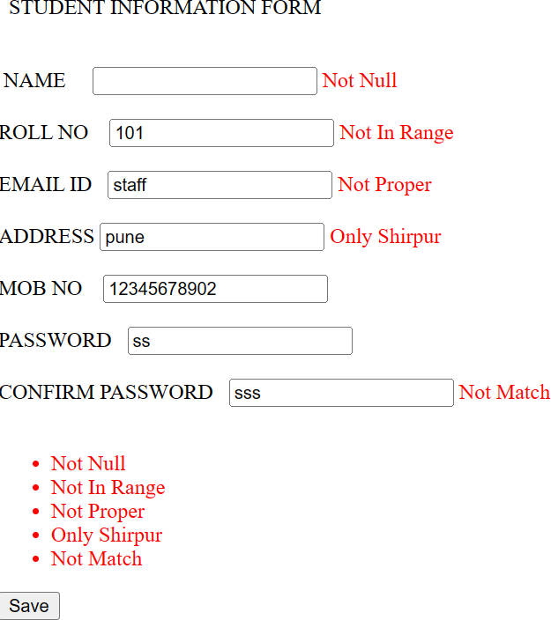

# If type Correct Information output is:

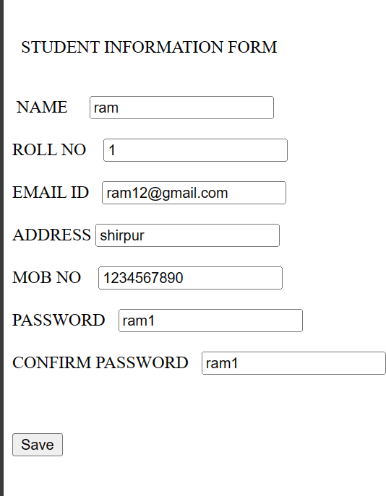

**Assignment No.5:**

**Write an ASP.Net Program to Demonstrate Use of Intrinsic Objects.**

WebForm1.aspx

<%@ Page Language="C#" AutoEventWireup="true" CodeBehind="WebForm1.aspx.cs" Inherits="WebApplication5.WebForm1" %>

<!DOCTYPE html PUBLIC "-//W3C//DTD XHTML 1.0 Transitional//EN" "http://www.w3.org/TR/xhtml1/DTD/xhtml1-transitional.dtd">

<html xmlns="http://www.w3.org/1999/xhtml">

<head id="Head1" runat="server">

<title>Intrinsic Objects Demo</title>

</head>

<body>

<form id="form1" runat="server">

<div>

<h1>Intrinsic Objects Demo</h1>

<p>Current Date and Time: <%= DateTime.Now.ToString() %></p>

<p>User-Agent: <%= Request.UserAgent %></p>

<p>Client IP Address: <%= Request.UserHostAddress %></p>

<p>HTTP Method: <%= Request.HttpMethod %></p>

<p>Server.MapPath: <%= Server.MapPath("/") %></p>

</div>

</form>

</body>

</html>

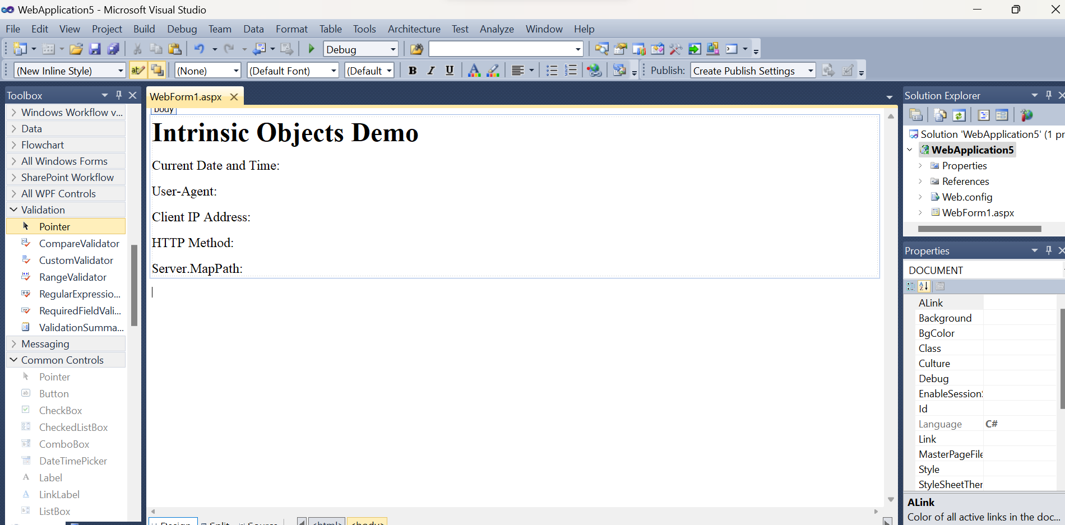

Output:

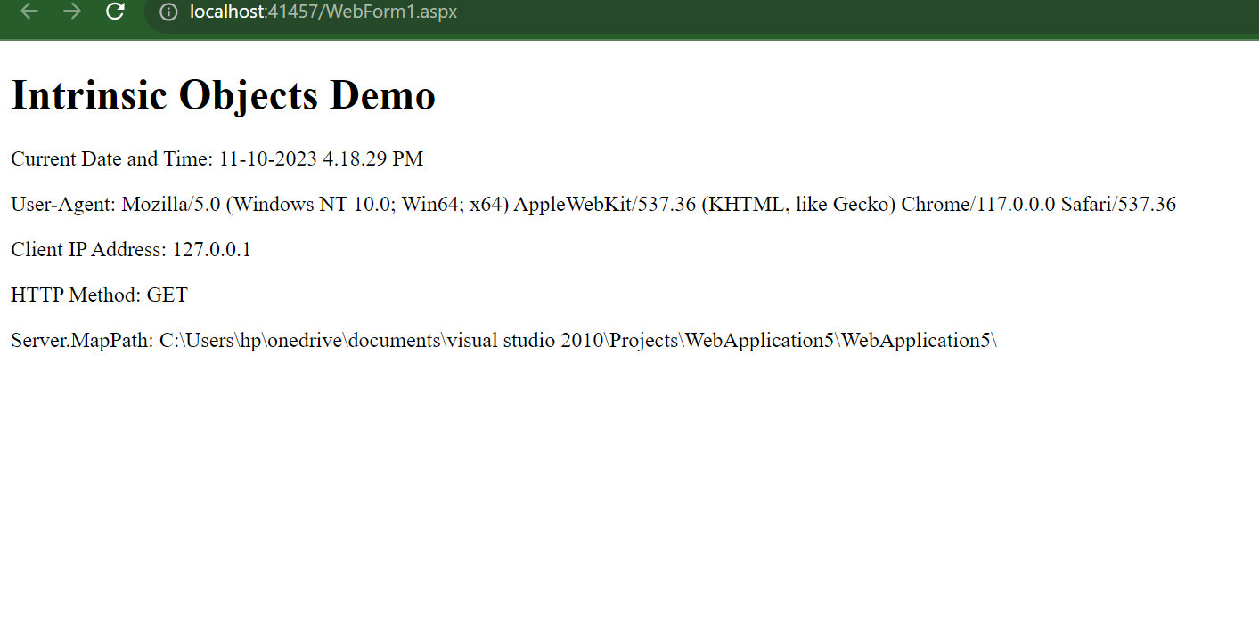

Assignment No 6.

Write an Asp.net Program to demonstrate Application and session scope variable using Global.asax file.

**Default.aspx**

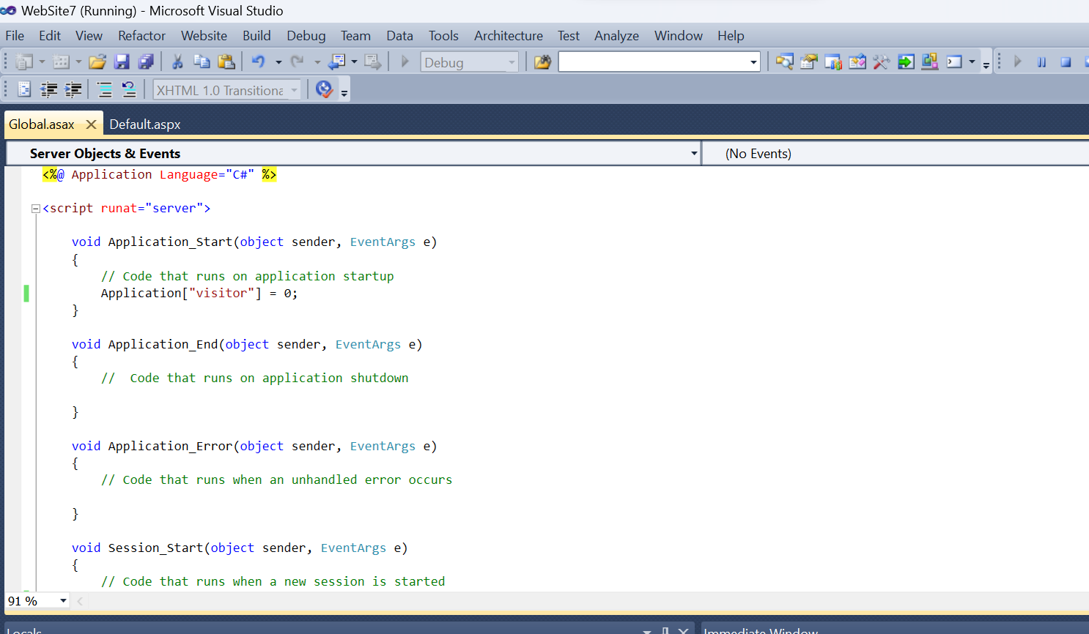

**Global.asax**





**Output**

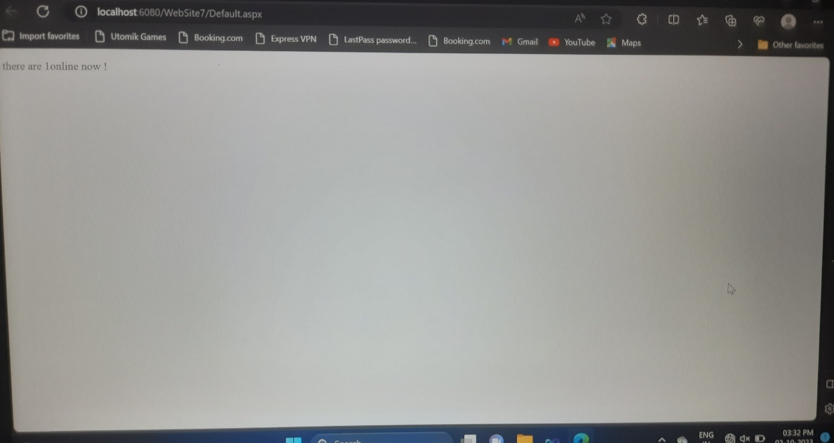

**Assignment No :- 7**

**Write an Asp.net program to demonstrate to use of Master Page.**

1. **Master page**

Step 1:-First You create ASP.NET empty website

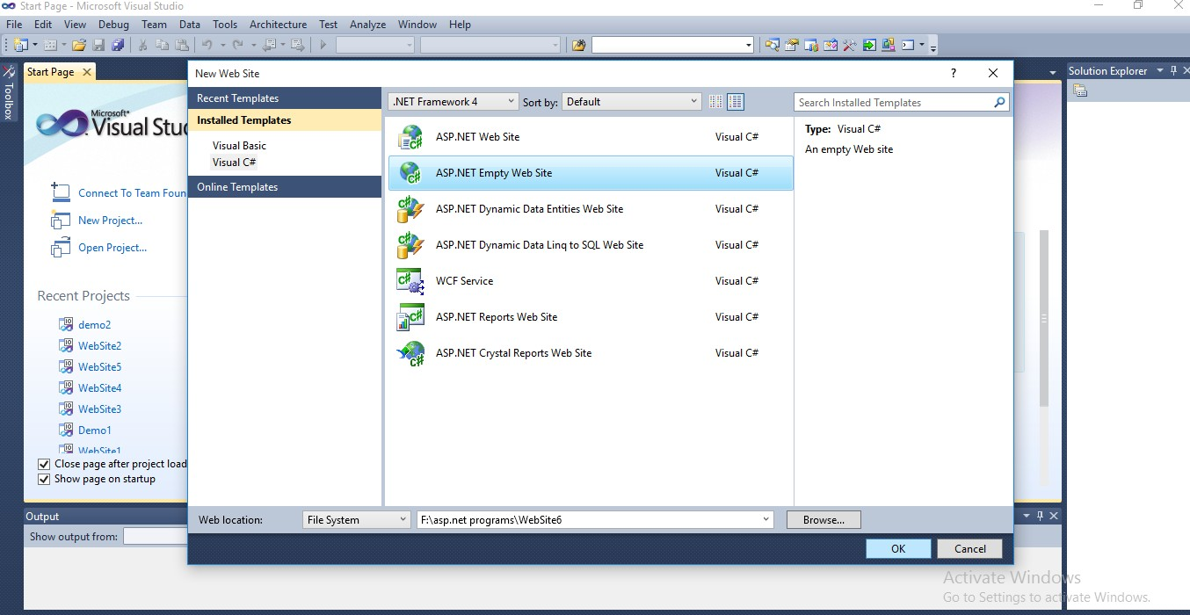

Step 2:- In Solution Explorer, right click on the name of your website and click on ‘add new item’.

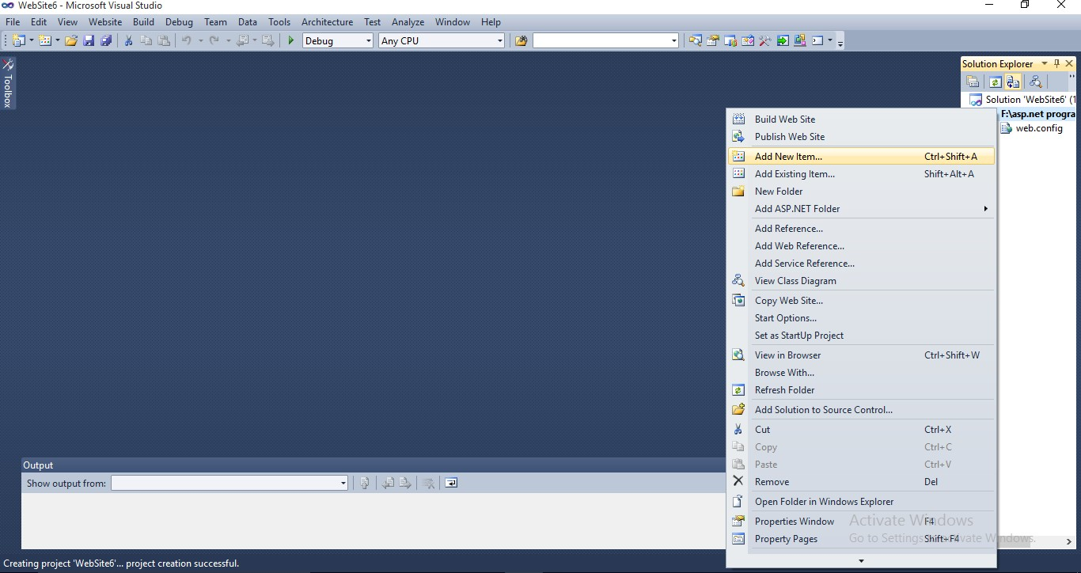

Step 3:- Under Visual Studio Template, click on master page and In name box type the name if you want to give it

Step 4:- Then Click on add button

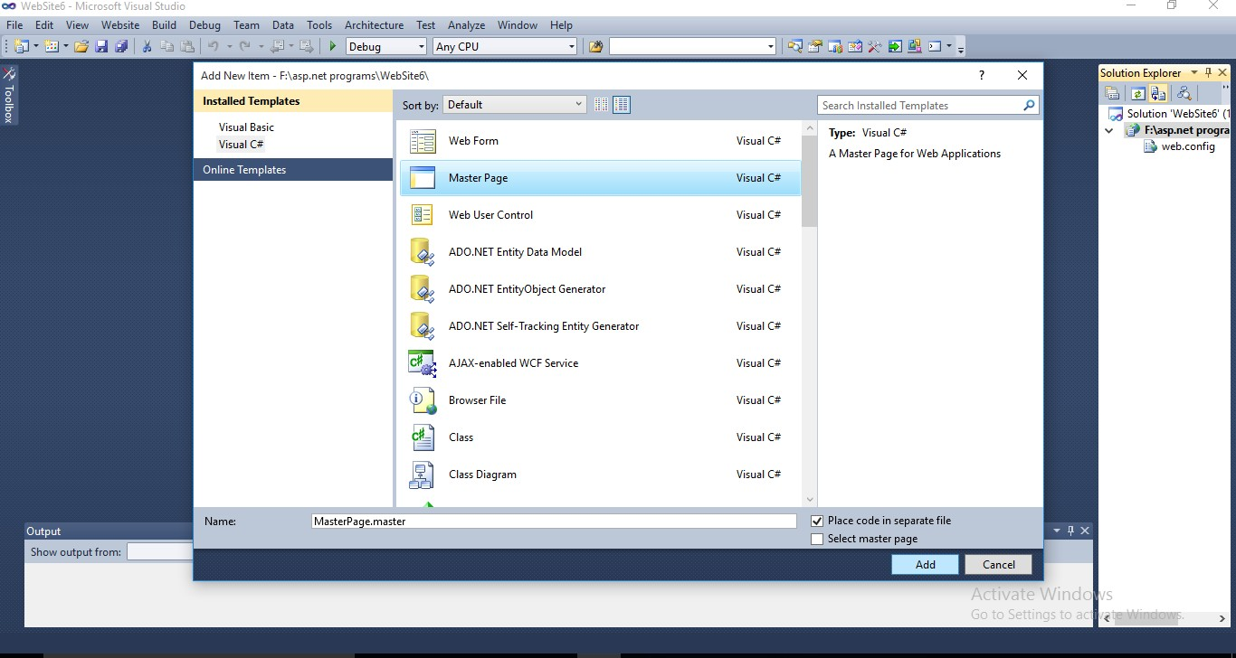

Step 5:- Then new master page opens in source view and Design it.

Step 6:- Add the ContentPlaceHolder control in content section of master page then Save it.

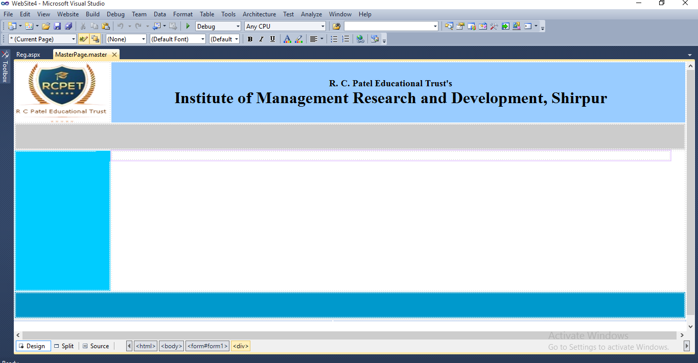

1. **Content Page**

Step 1:- In Solution Explorer, right click on the name of your website and click on ‘add new item’.

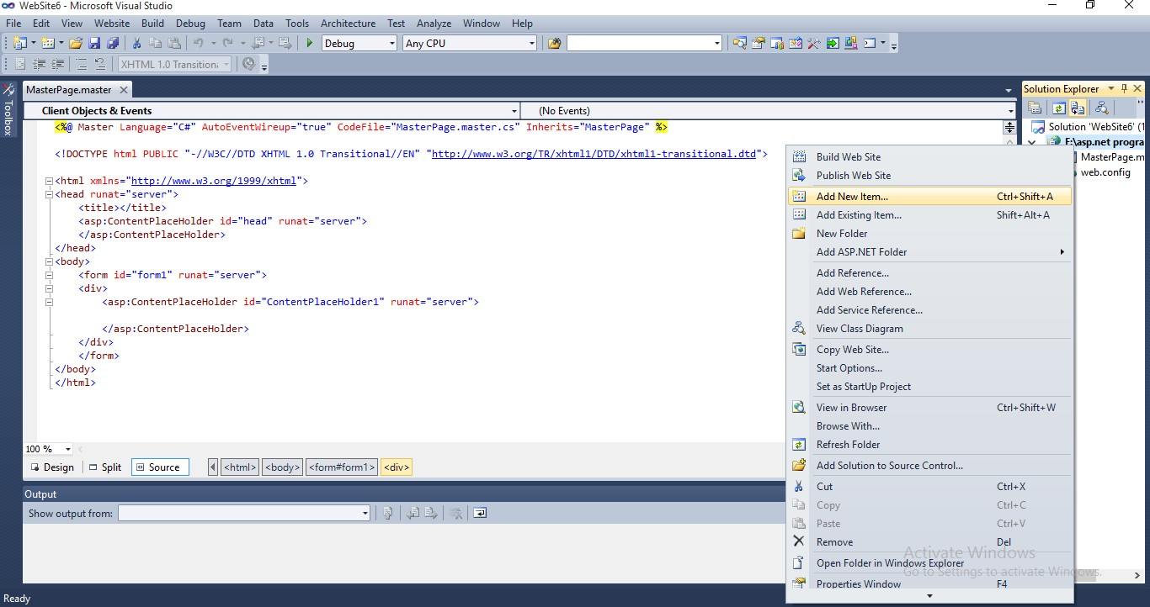

Step 2:- Under Visual Studio Template, click on Web form and In name box type the name if you want to give it.

Step 3:- Select the ‘Select master page’ check box and then click on add button.

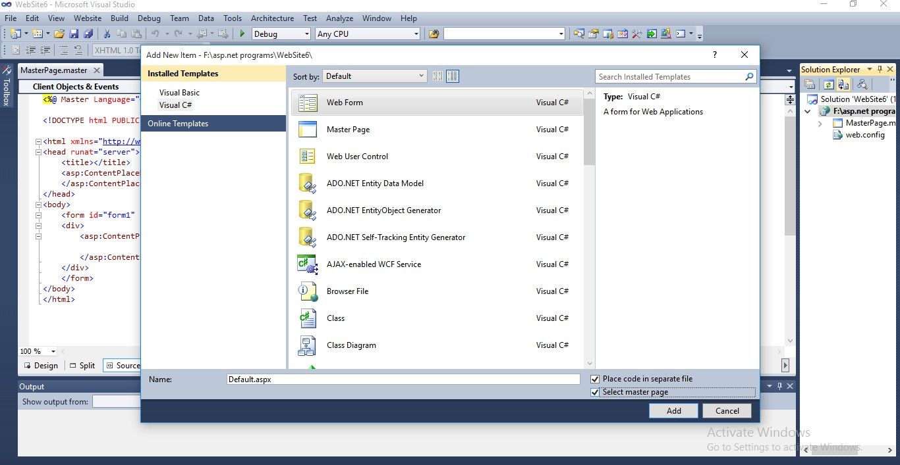

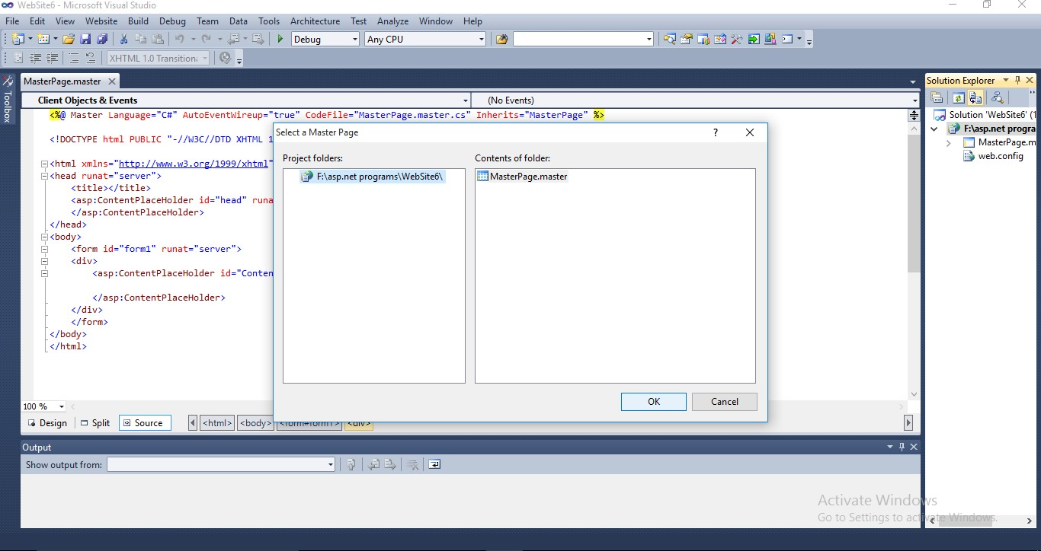Step 4:- The select master page dialog box appears then click on .masert page and then click on ok buuton

Step 5:- Then new .aspx file is created and you can add content in this file.

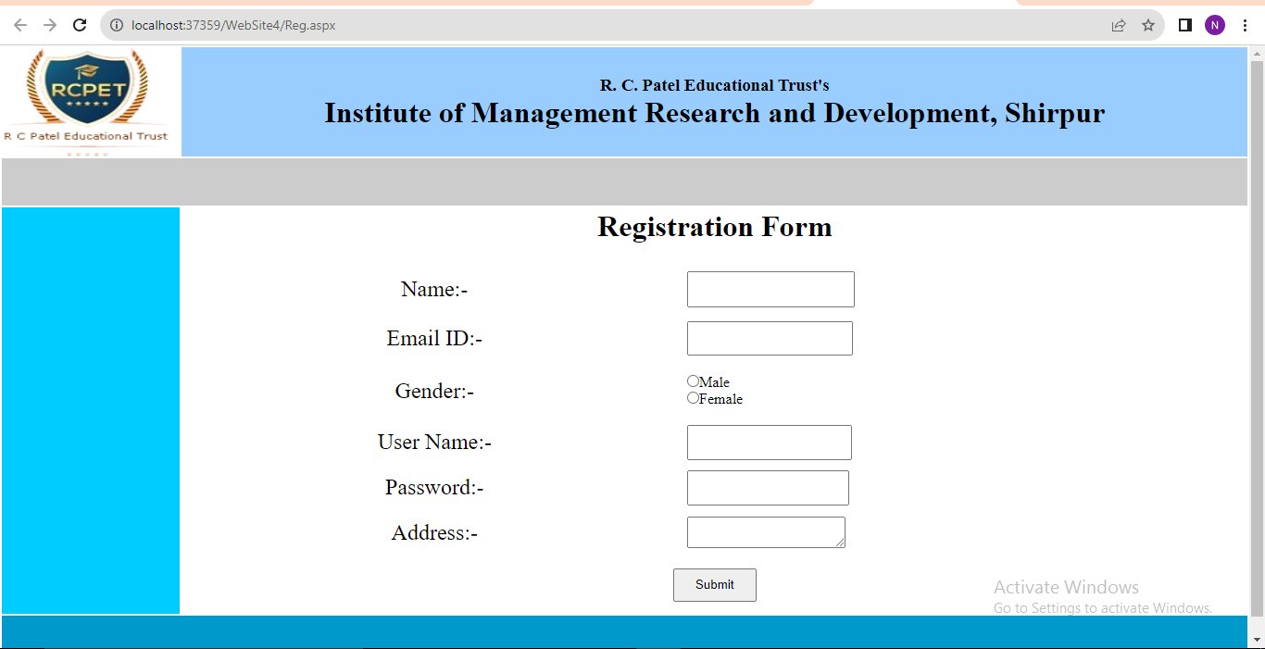

**Assignment No.8:**

**Write an Asp.net page that use the connection object to connect the data base and display information using Datagridview controls.**

**Default.aspx**

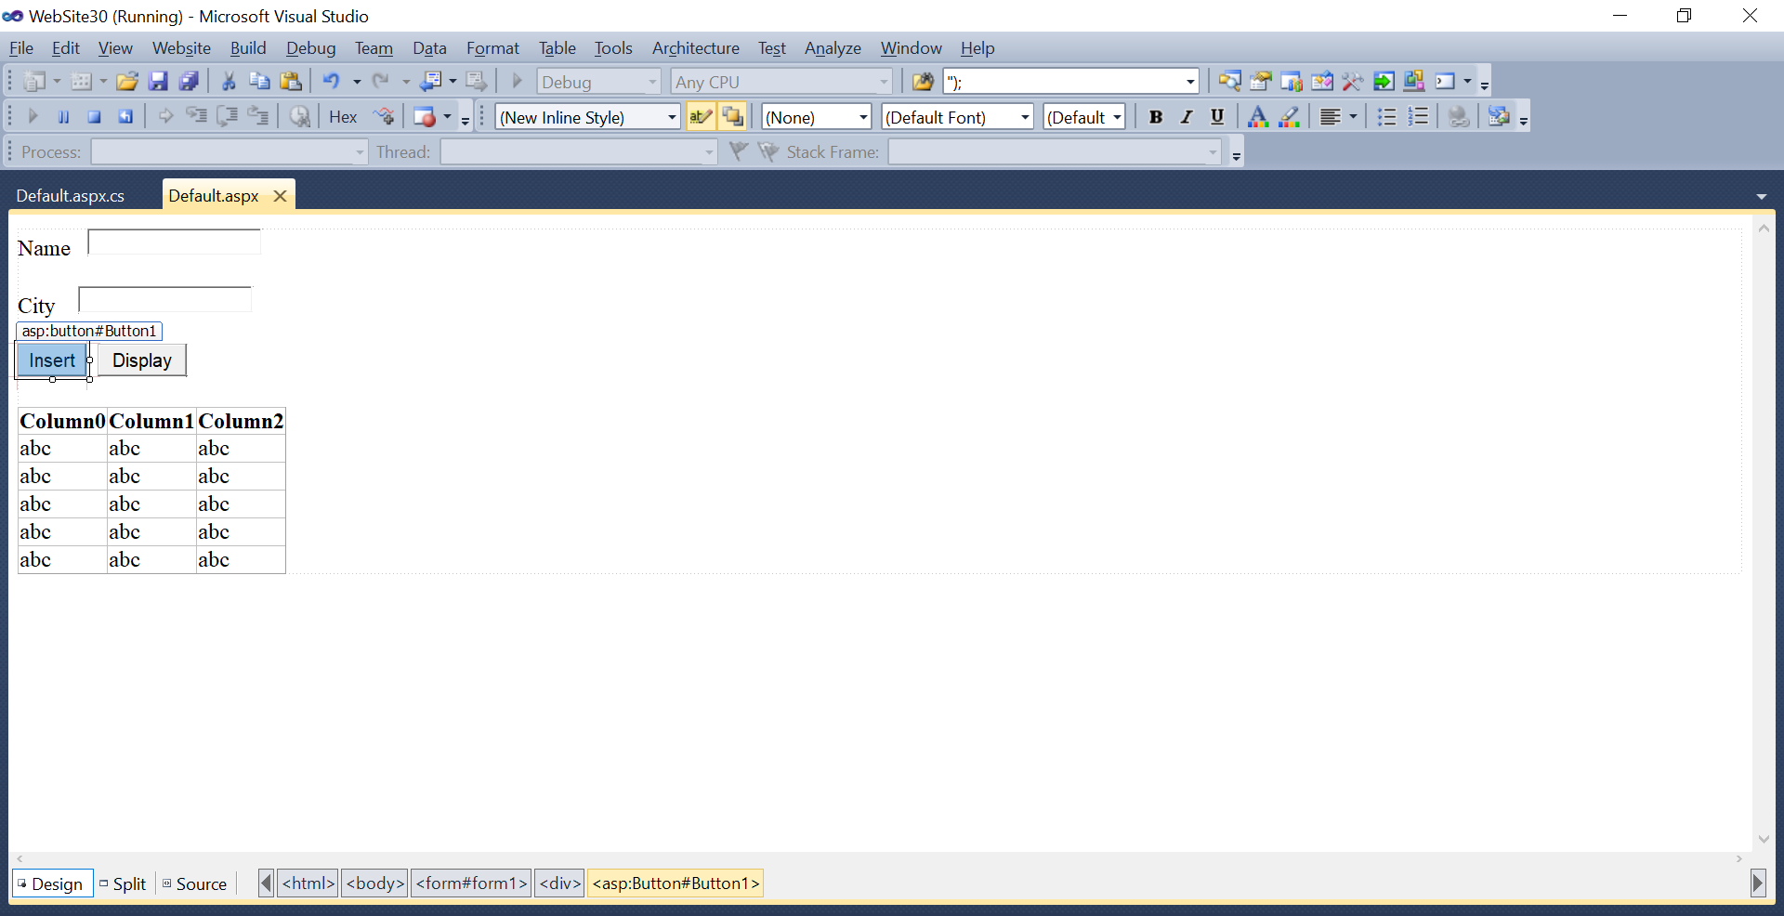

**Default.aspx.cs**

using System;

using System.Collections.Generic;

using System.Linq;

using System.Web;

using System.Web.UI;

using System.Web.UI.WebControls;

using System.Data.OleDb;

using System.Data;

public partial class _Default : System.Web.UI.Page

{

OleDbConnection con = new OleDbConnection("Provider=Microsoft.ACE.OLEDB.12.0;Data Source=C:\\Users\\HP\\Documents\\ritu\\Database3.accdb");

protected void Page_Load(object sender, EventArgs e)

{

}

//Insert Data

protected void Button1_Click(object sender, EventArgs e)

{

con.Open();

OleDbCommand cmd = new OleDbCommand("insert into t1 values('" + TextBox1.Text + "','" + TextBox2.Text + "')", con);

cmd.ExecuteNonQuery();

con.Close();

Response.Write("<script LANGUAGE='JavaScript'>alert('Data insert sucessfully...!')</script>");

}\

//Display

protected void Button2_Click(object sender, EventArgs e)

{

DataTable dt = new DataTable();

con.Open();

OleDbDataAdapter da = new OleDbDataAdapter("select * from t1", con);

da.Fill(dt);

GridView1.DataSource = dt;

GridView1.DataBind();

con.Close();

}

}

**Output :**

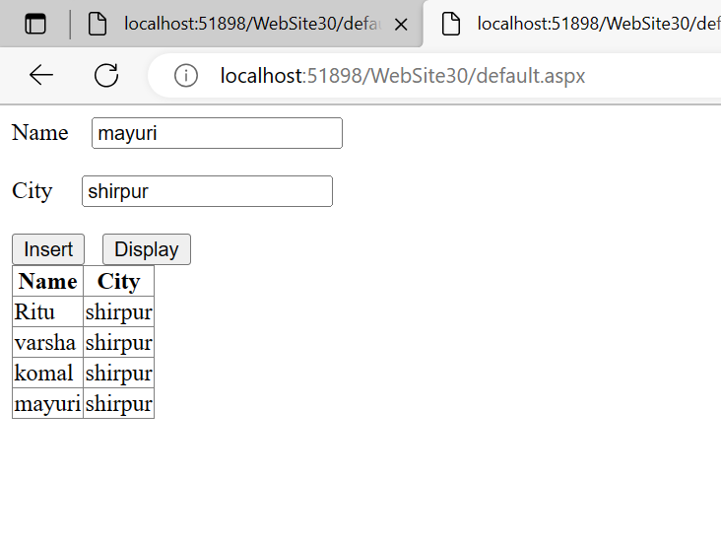

**Practical No 9.**

**Demonstrate website Nevigation control using Sitemap file.**

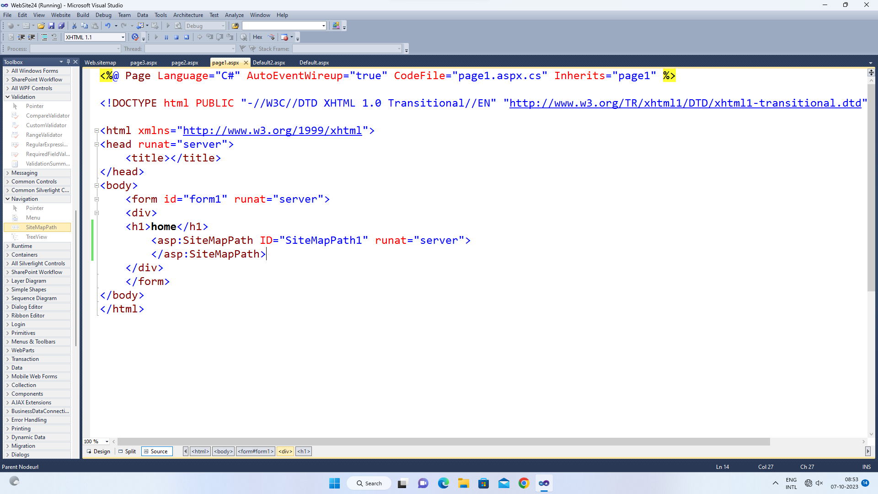

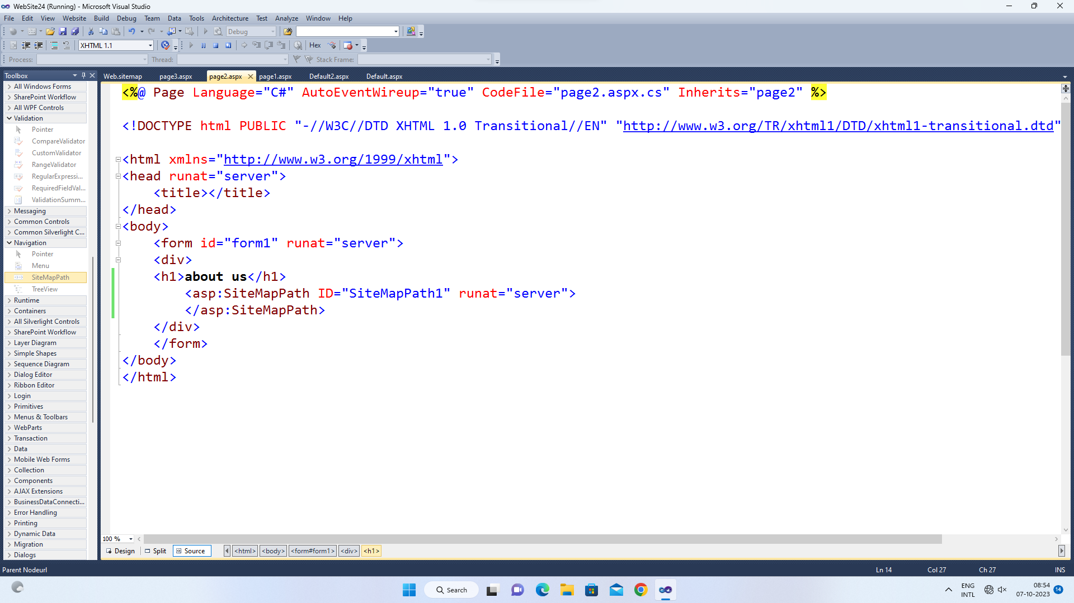

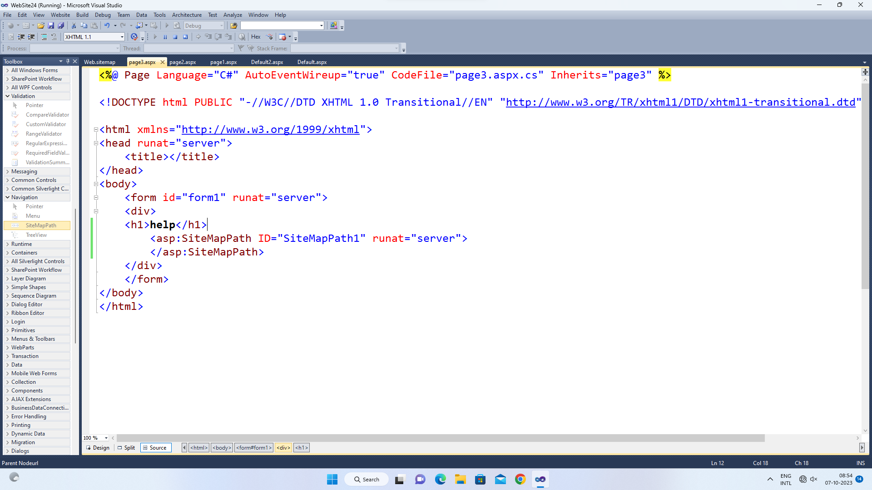

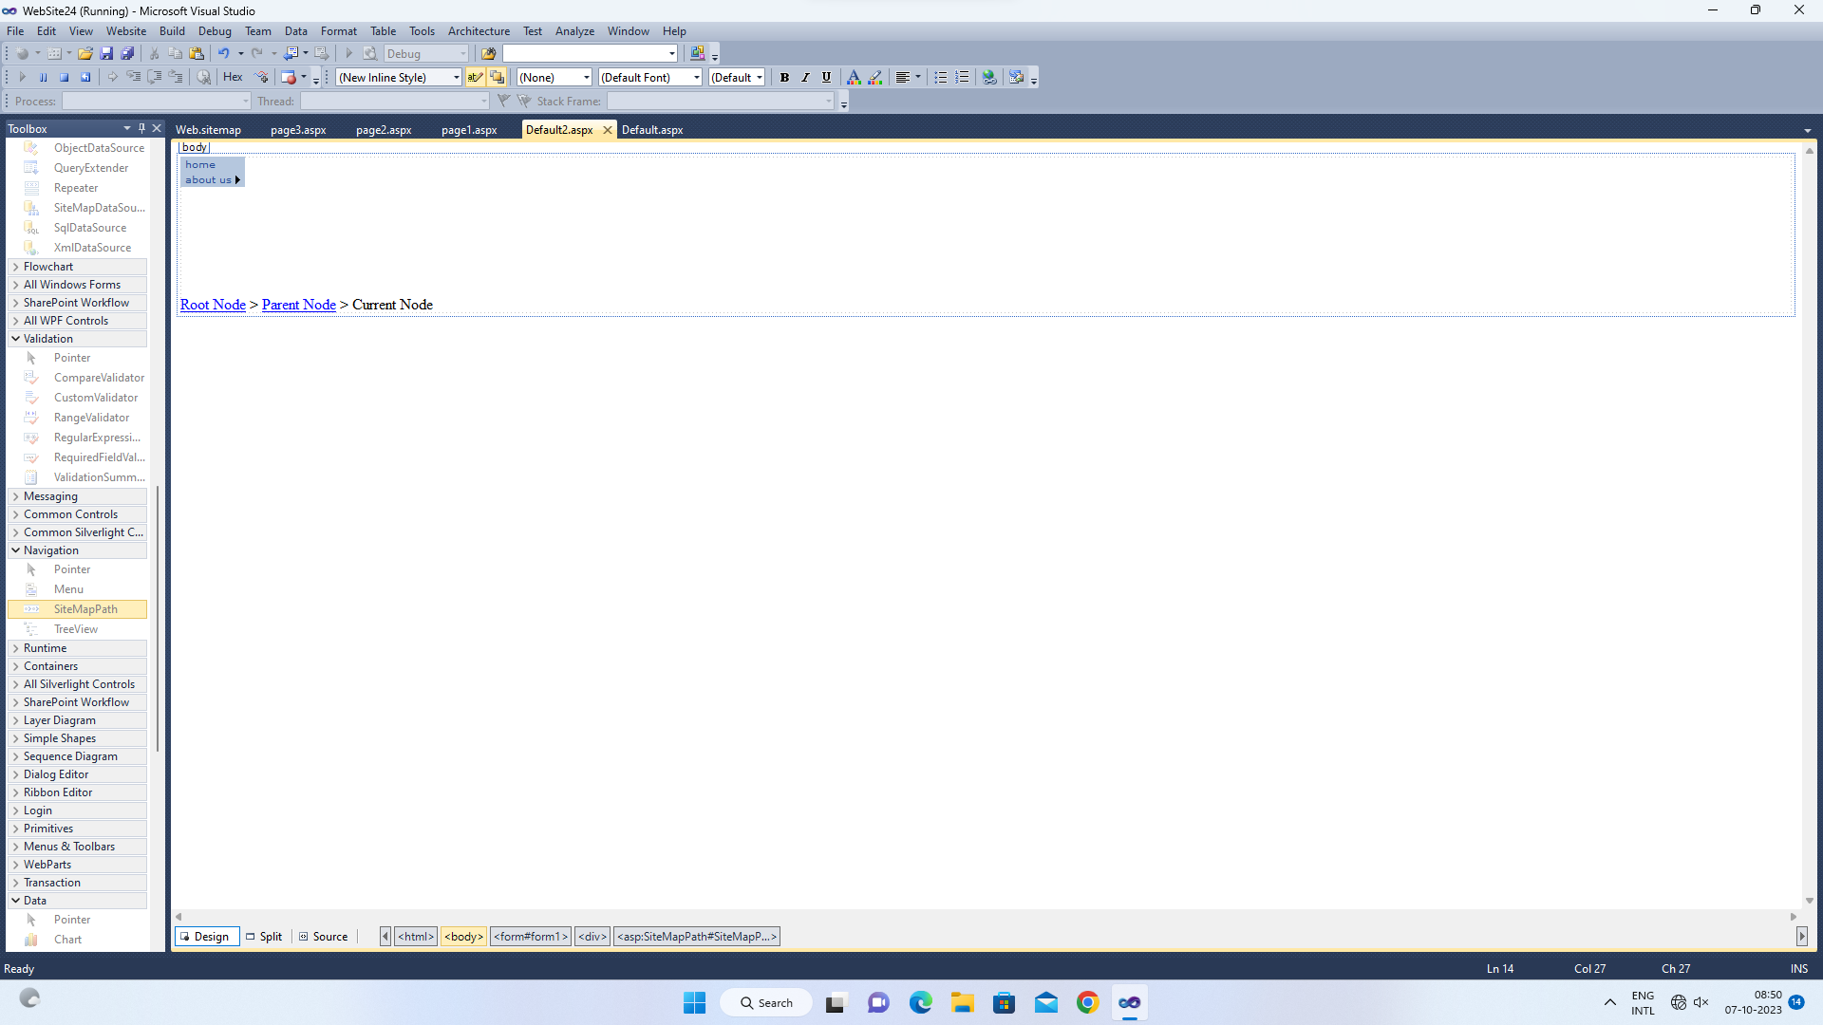

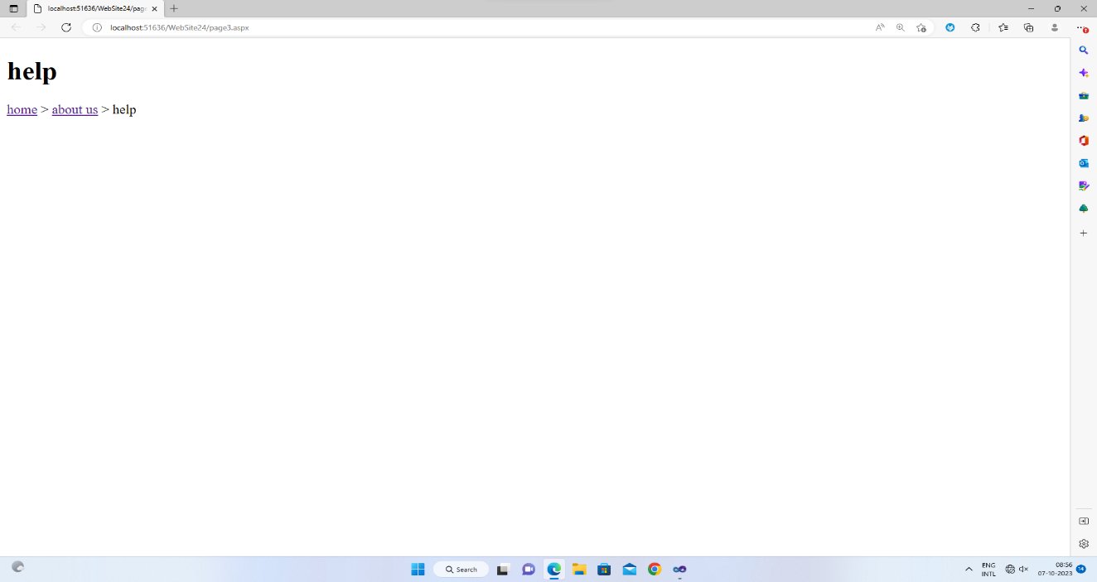

**Assignment No.10:**

**Demonstrate Website Navigation Control Using Treeview File.**

Step 1: Open Visual studio 2008.

Step 2: Select file-new-website rename as a navigation control and browser it location.

Step 3: Then VS2008 open with web from as Default.aspx.

Step 4: Place the Tree View control on web form from Navigation Control panel.

Step 5: Go to properties of Tree View Control and Select Nodes property.

Step 6: Add Number of Nodes in Tree View and give text and navigation url to Nodes.

Step 7: Press F5 to Text the Tree View.

Output :-

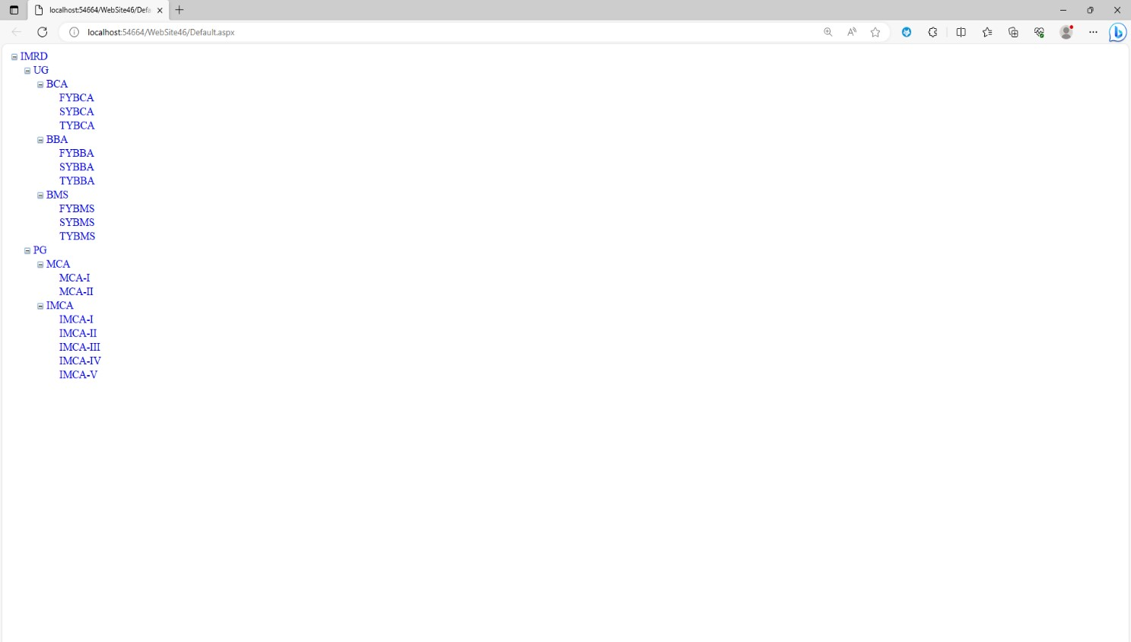

**Assignment No.11:**

**Demonstration of ASP.Net Objects ( HTTP ApplicationState , HTTP SessionState**).

**Session.aspx**

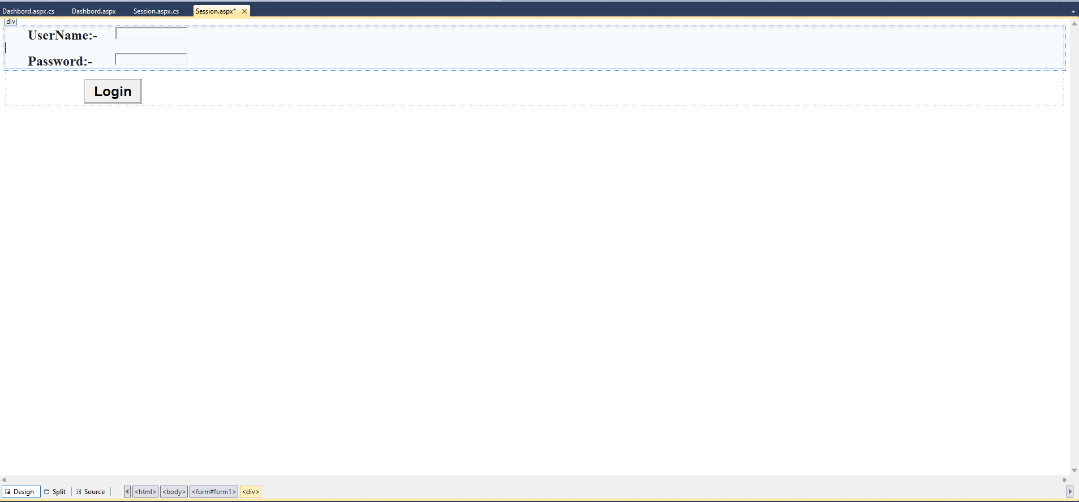

**Session.aspx.cs**

using System;

using System.Collections.Generic;

using System.Linq;

using System.Web;

using System.Web.UI;

using System.Web.UI.WebControls;

public partial class Session : System.Web.UI.Page

{

protected void Page_Load(object sender, EventArgs e)

{

}

protected void Button1_Click(object sender, EventArgs e)

{

if (TextBox1.Text == "rcp" && TextBox2.Text == "imrd")

{

Session["username"] = TextBox1.Text;

Response.Redirect("Dashbord.aspx");

}

else

{

Response.Write("user name or password not correct");

}

}

}

**Dashbord.aspx**

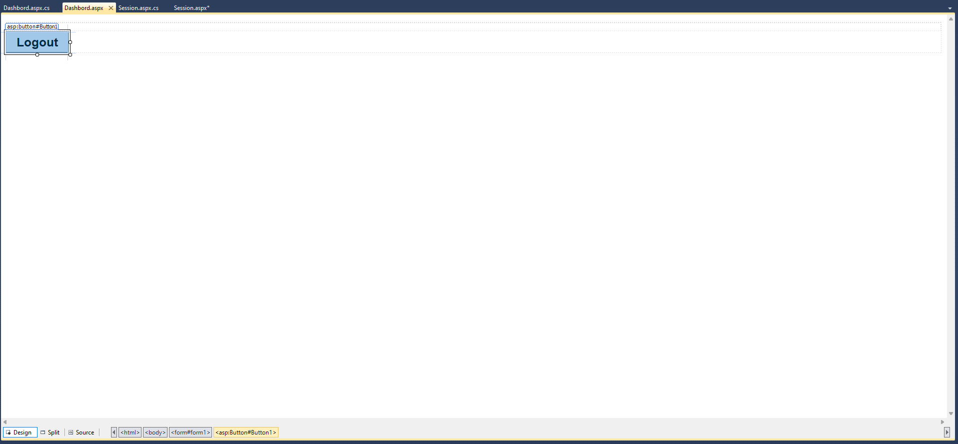

**Dashbord.aspx.cs**

using System;

using System.Collections.Generic;

using System.Linq;

using System.Web;

using System.Web.UI;

using System.Web.UI.WebControls;

public partial class Dashbord : System.Web.UI.Page

{

protected void Page_Load(object sender, EventArgs e)

{

Response.Write("Welcome user=" + Session["username"]);

}

protected void Button1_Click(object sender, EventArgs e)

{

Session.Abandon();

Response.Redirect("Session.aspx");

}

}

**Output:-**

**If user name and password is not correct.**

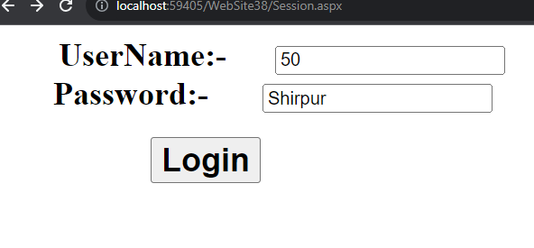

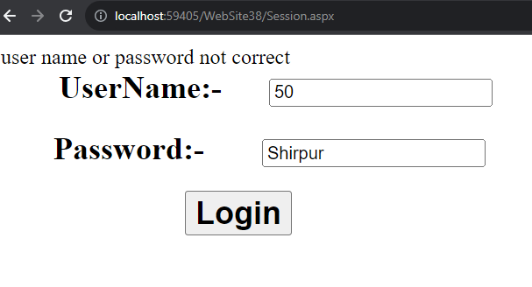

**If user name and password are correct.**

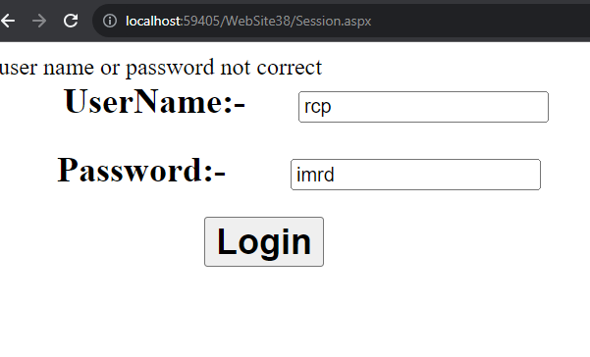

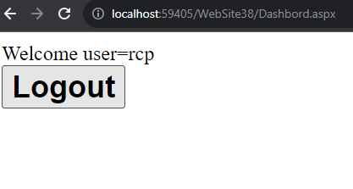

**Assignment No.12:**

**Write an ASP.Net Program to Demonstrate Use of ASP.Net Textbox , Checkbox , RadioButton and Button Control in Simple Web Form.**

**Default.aspx :-**

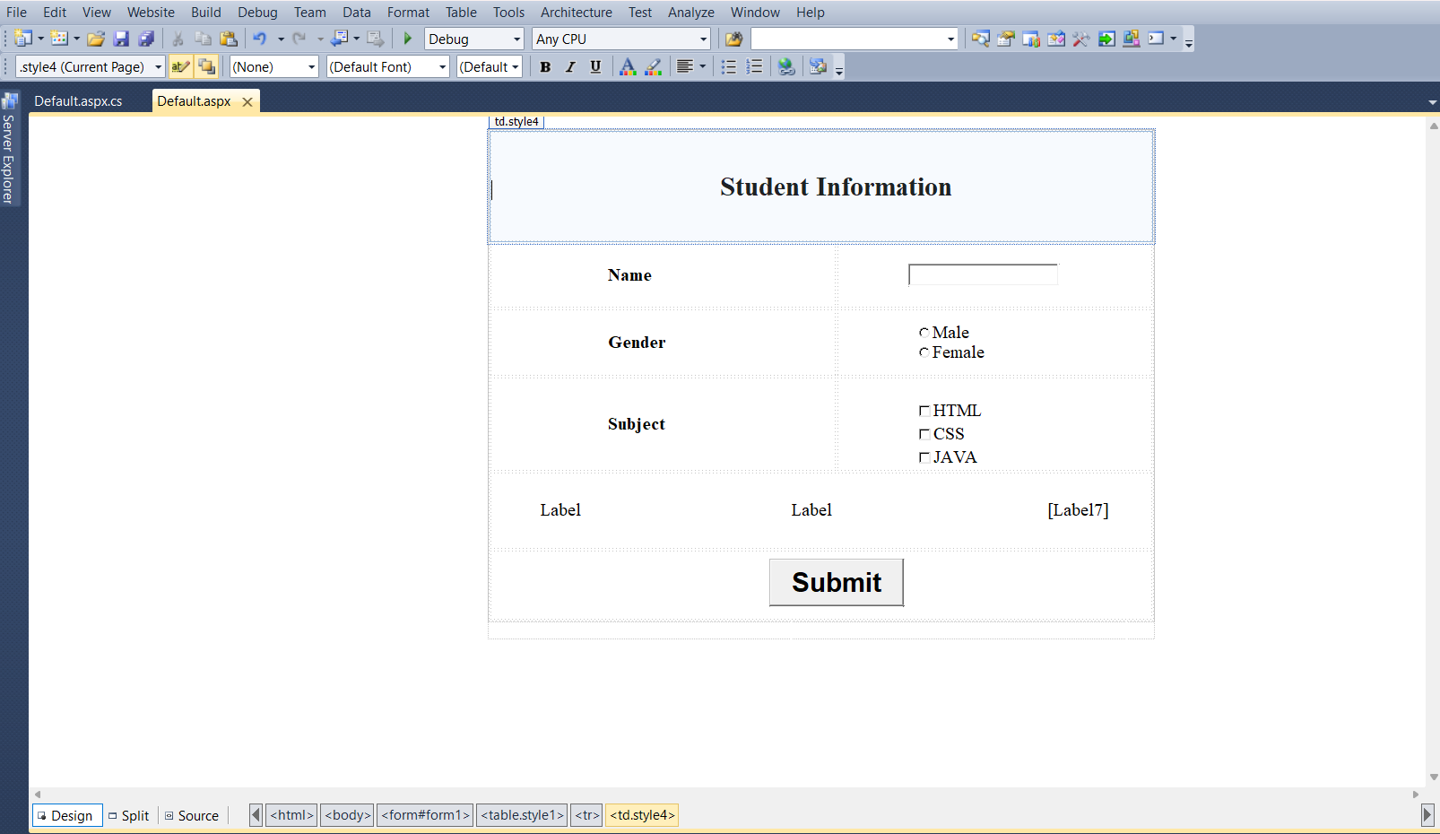

**Default.aspx.cs :-**

using System;

using System.Collections.Generic;

using System.Linq;

using System.Web;

using System.Web.UI;

using System.Web.UI.WebControls;

public partial class _Default : System.Web.UI.Page

{

protected void Page_Load(object sender, EventArgs e)

{

}

protected void Button1_Click(object sender, EventArgs e)

{

Label5.Text = TextBox1.Text;

if (RadioButton1.Checked == true)

{

Label6.Text = RadioButton1.Text;

}

else

{

Label6.Text = RadioButton2.Text;

}

foreach(ListItem Item in CheckBoxList1.Items)

{

if (Item.Selected)

{

Label7.Text += Item.Text + " ";

}

}

}

}

**Output :-**

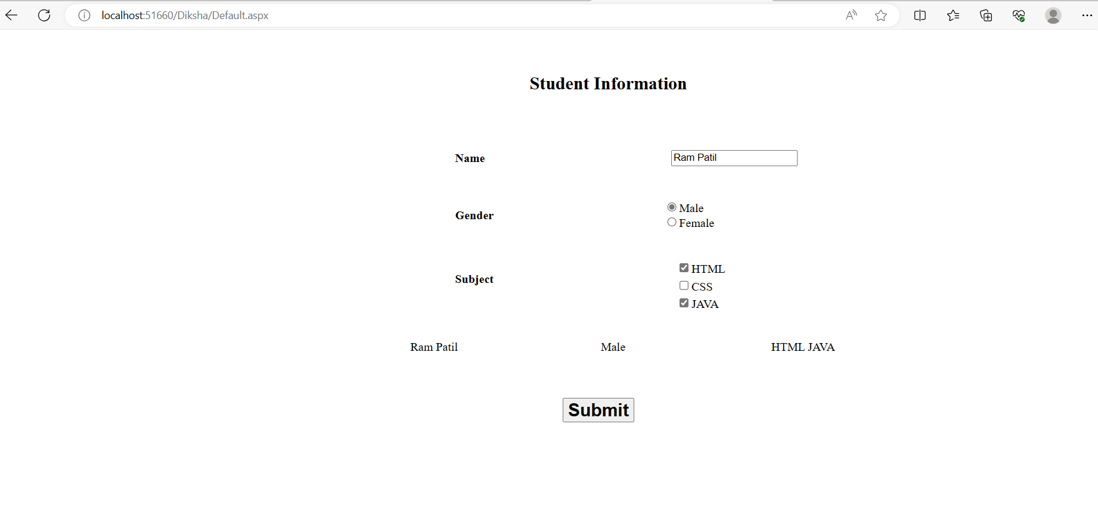

**Assignment No :- 13**

**Write asp.net program to Demonstrate Use of asp.net DropDownlist , Listbox and Button control in simple web form.**

**Default.aspx**

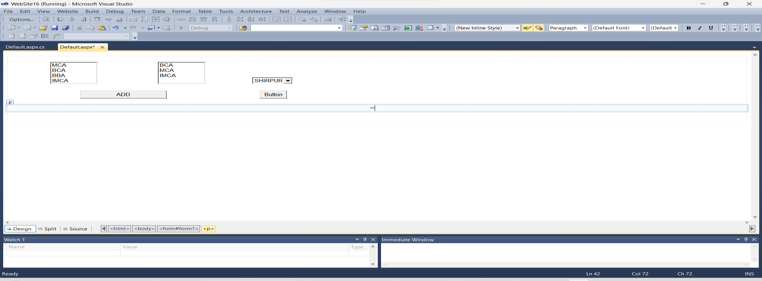

**Default.aspx.cs**

using System;

using System.Collections.Generic; using System.Linq;

using System.Web; using System.Web.UI;

using System.Web.UI.WebControls;

public partial class _Default : System.Web.UI.Page

{

protected void Page_Load(object sender, EventArgs e)

{

}

protected void Button1_Click(object sender, EventArgs e)

{

if (ListBox1.SelectedItem != null)

{

string SelectedItem = ListBox1.SelectedItem.ToString(); ListBox2.Items.Add(SelectedItem);

}

}

protected void Button3_Click(object sender, EventArgs e)

{

if (DropDownList1.SelectedValue=="")

{

Label1.Text="Please Select a City ";

}

else

{

Label1.Text="your choice is "+ DropDownList1.SelectedValue;

}

}

}

**Output:**

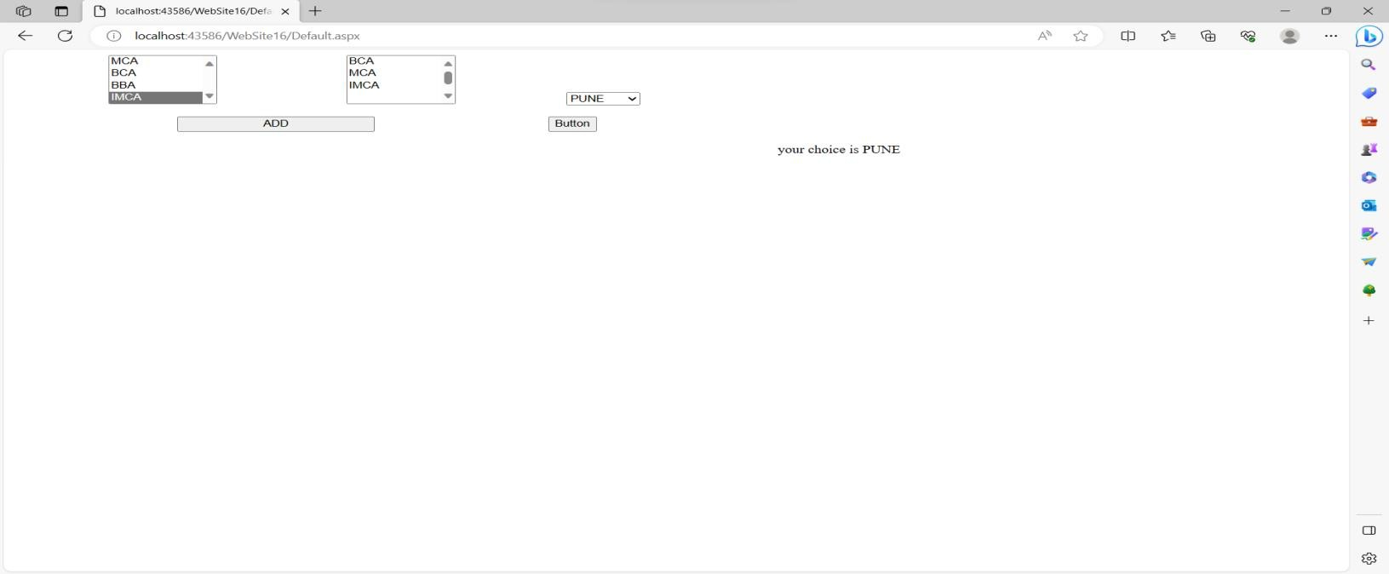

**Assignment No :- 14**

**Demonstrate How to Detect Browser Capabilities in ASP.NET**

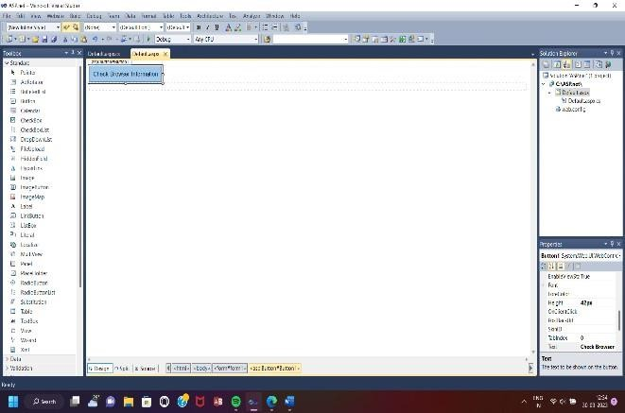**Default.aspx**

**Default.aspx.cs**

using System;

using System.Collections.Generic; using System.Linq; using System.Web; using System.Web.UI;

using System.Web.UI.WebControls;

public partial class _Default : System.Web.UI.Page

{

protected void Page_Load(object sender, EventArgs e)

{

}

protected void Button1_Click(object sender, EventArgs e)

{

HttpBrowserCapabilities K; K = Request.Browser;

Response.Write("<h1>Browser Information And Capabilities</h1>");

Response.Write("Browser Name is :-" + K.Browser + "<br>"); Response.Write("Browser Version is :-" + K.Version + "<br>"); Response.Write("Browser Support to tables:-" + K.Tables + "<br>"); Response.Write("Browser Support to JavaScript :-" + K.JavaScript +

"<br>");

Response.Write("Browser Support to VBScript :-" + K.VBScript + "<br>"); Response.Write("Browser Support to Frames :-" + K.Frames + "<br>"); Response.Write("Browser Support to BackGround Sound :-" +

K.BackgroundSounds+ "<br>");

Response.Write("Browser Support to Cookies :-" + K.Cookies + "<br>"); Response.Write("Browser ID is :-" + K.Id + "<br>"); Response.Write("Browser PlatForm is :-" + K.Platform+

"<br>");

}

**OutPut:**

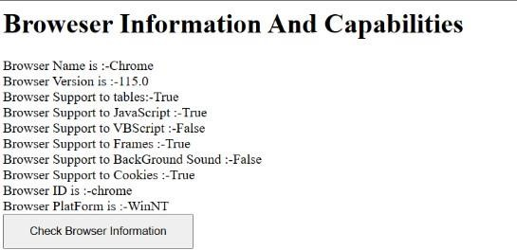

**Assignment No :- 15**

**Demonstrate how to handle Application Level Errors in ASP.NET .**

1. **Default.aspx File:-**

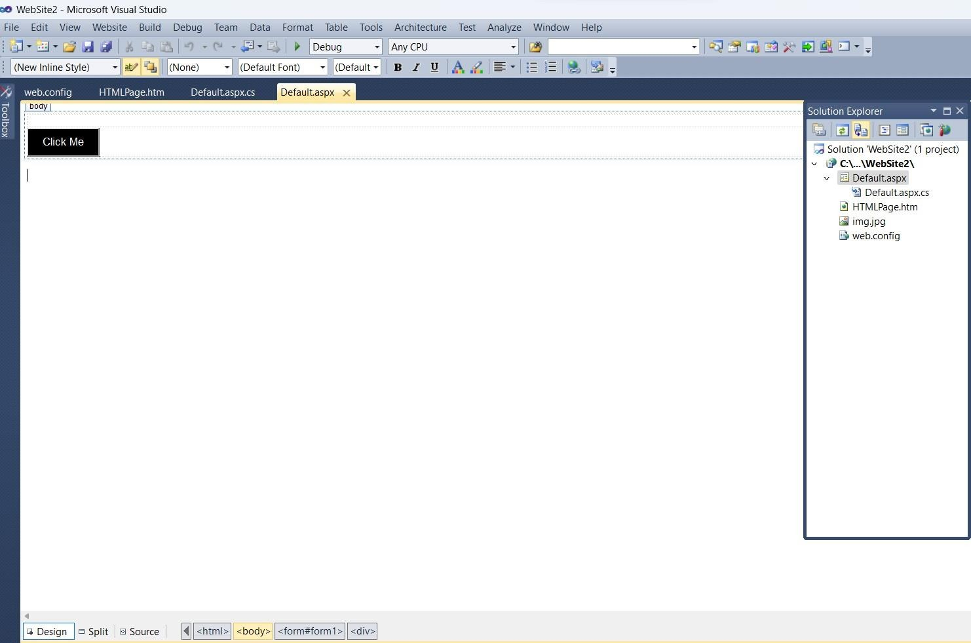

1. **Default.aspx.css File:-**

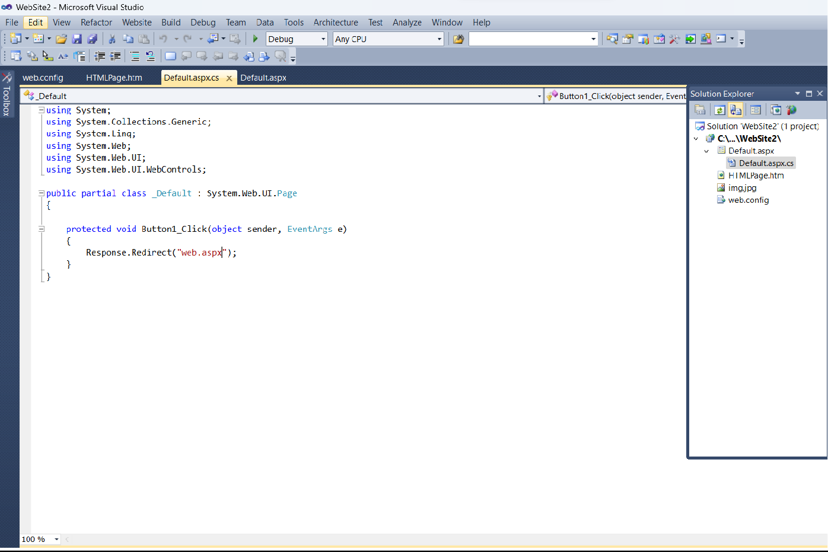

1. **HTMLPage.htm File:-**

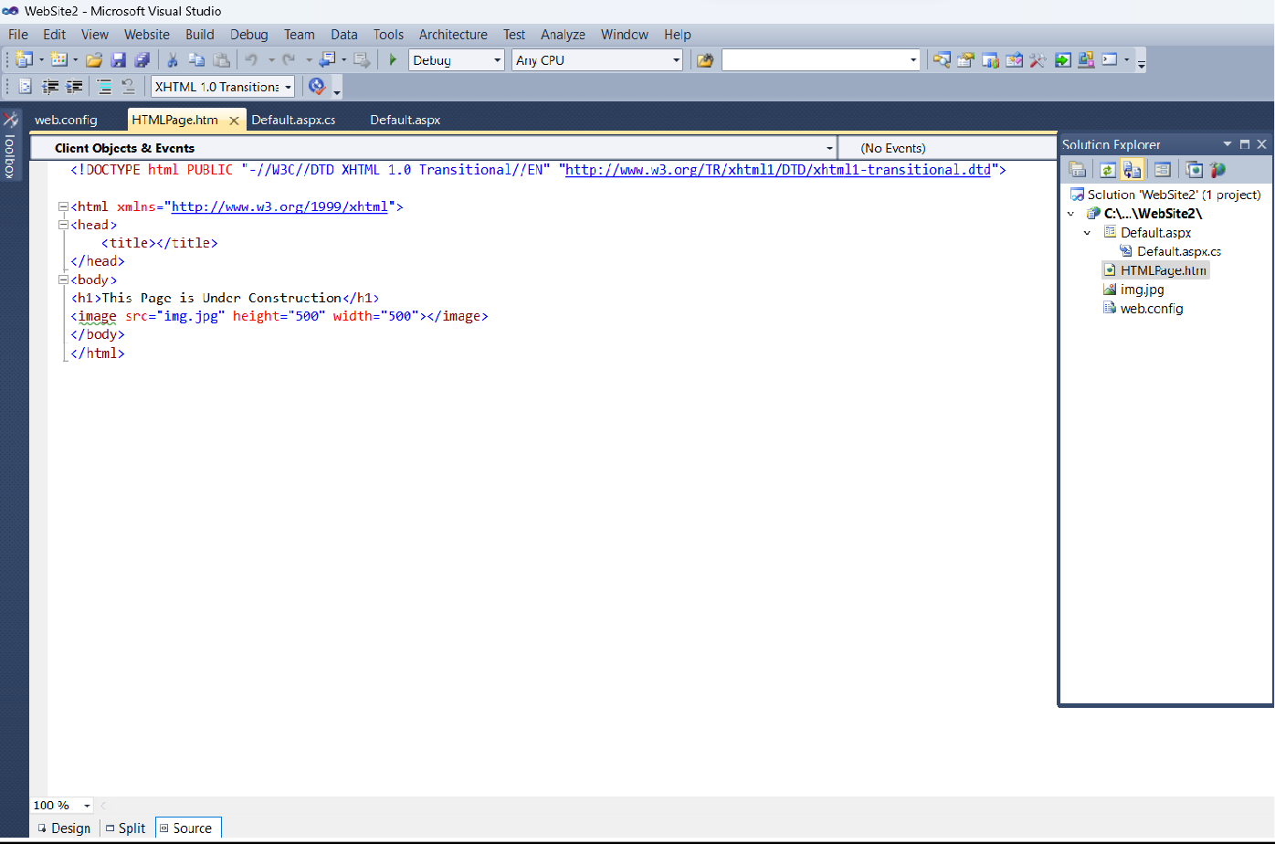

1. **Web.config File:-**

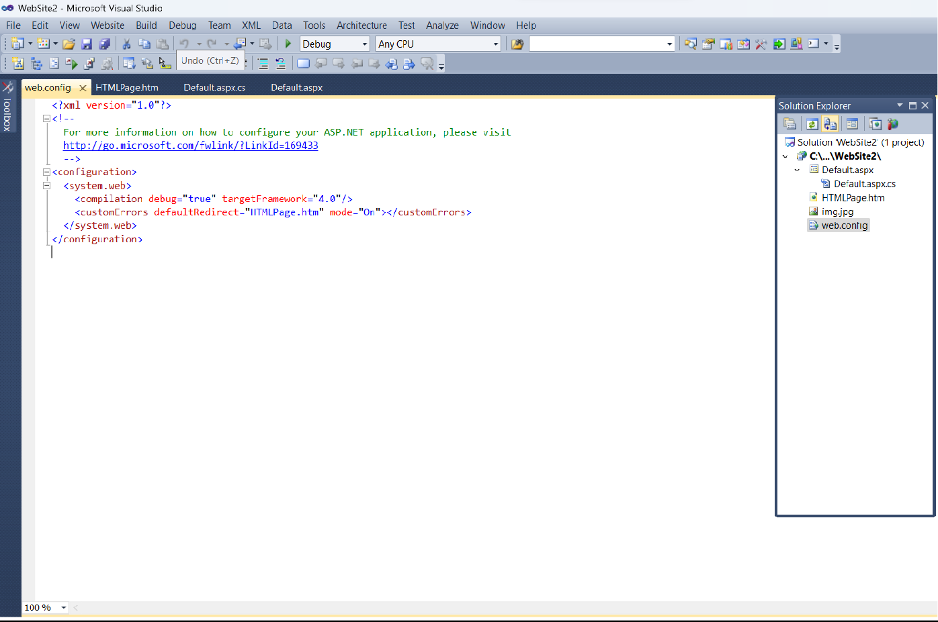

**Output**

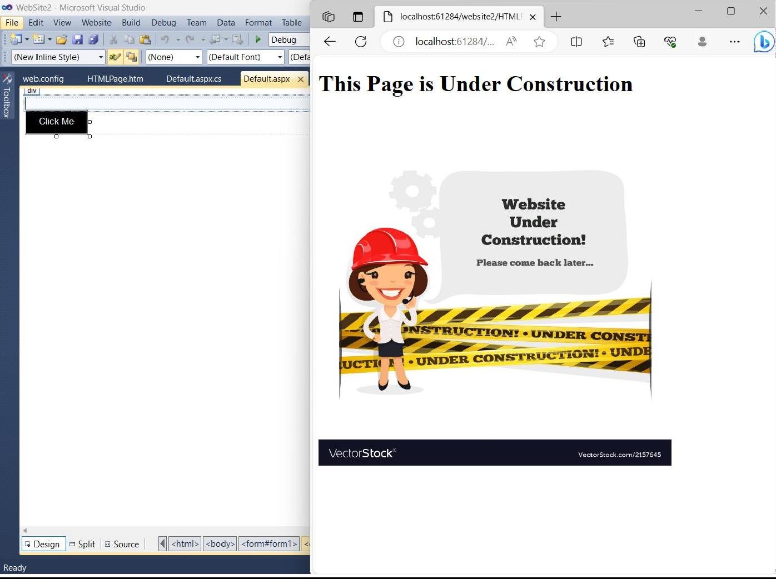

**Assignment No 16**

**Write an ASP.Net Program to Demonstrate use of Server.Transfer() and Request.QueryString.**

**1**

**)**

**Default.aspx file**

**:**

**-**

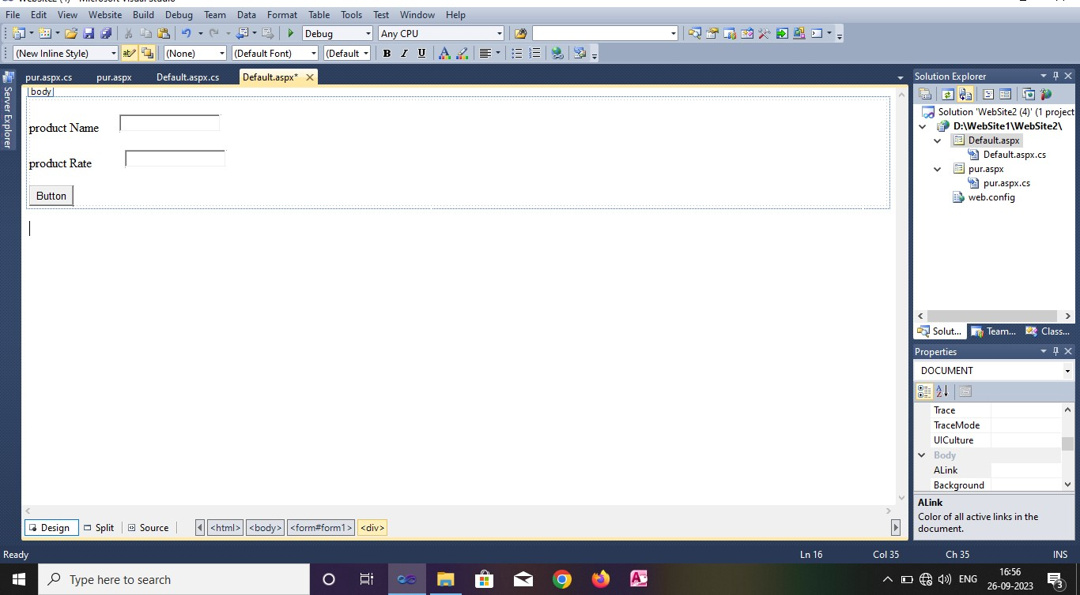

**pur.aspx file:-**

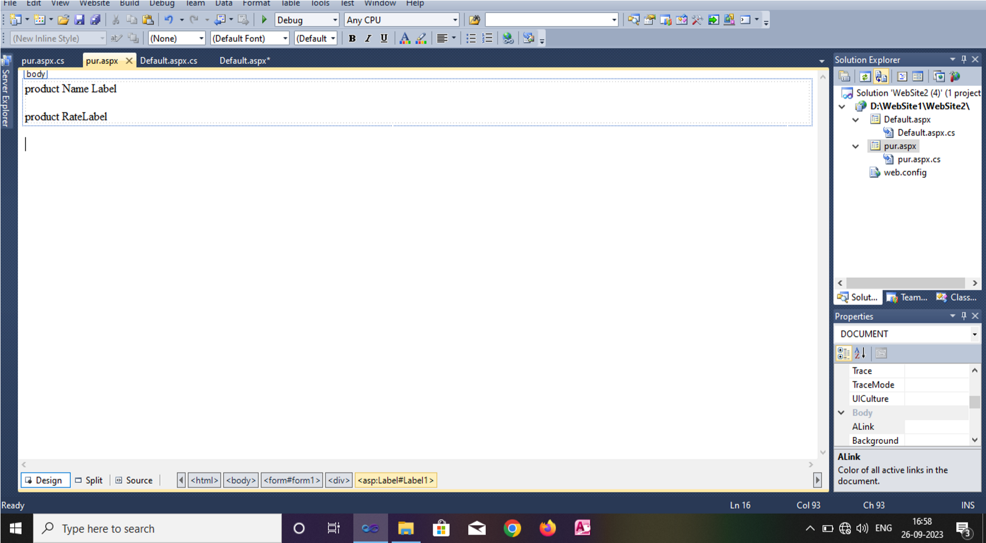

**pur.aspx.cs file**

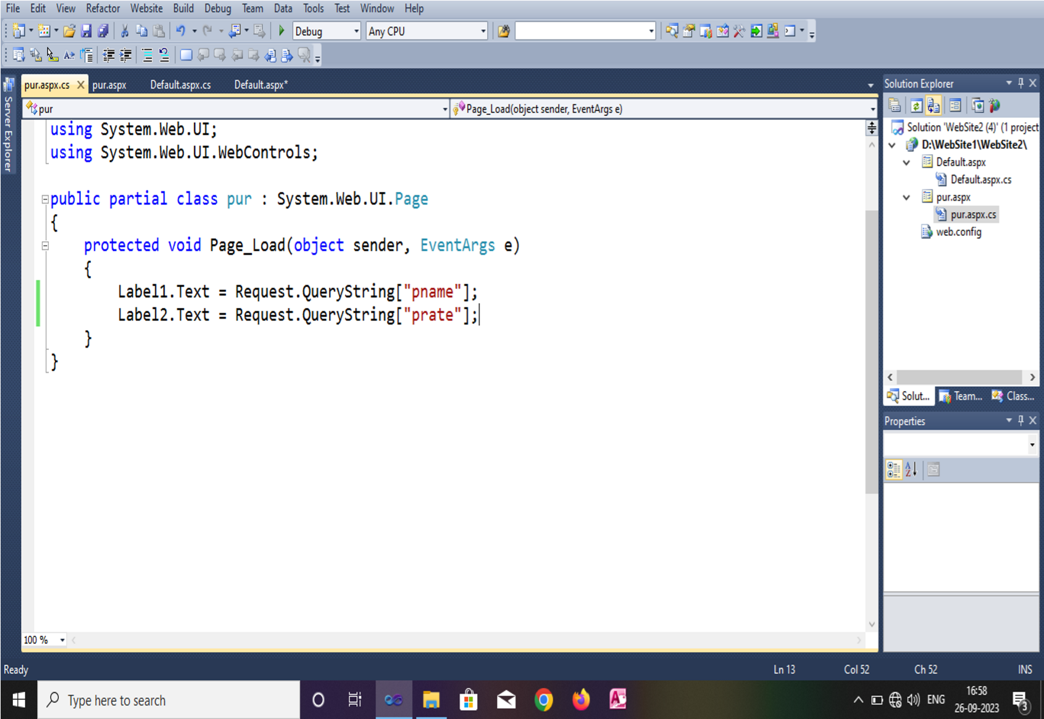

**Output:-**

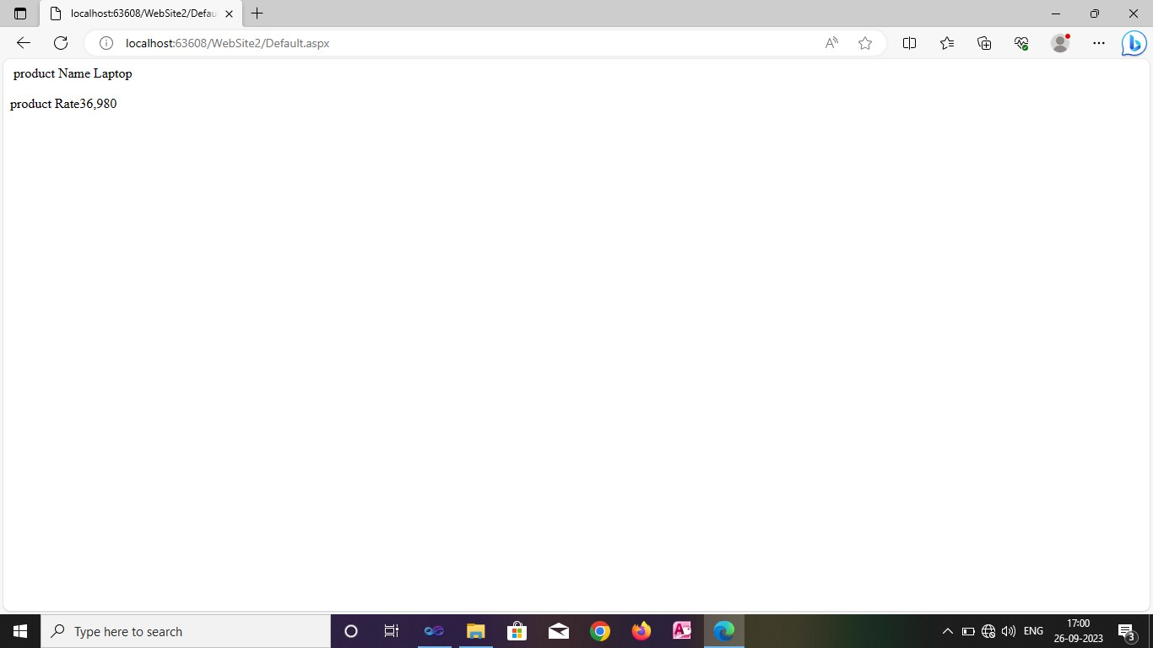

**Assignment No.17:**

**Write an ASP.Net Program to Demonstrate Insert , Display Operations with Microsoft Access Database .**

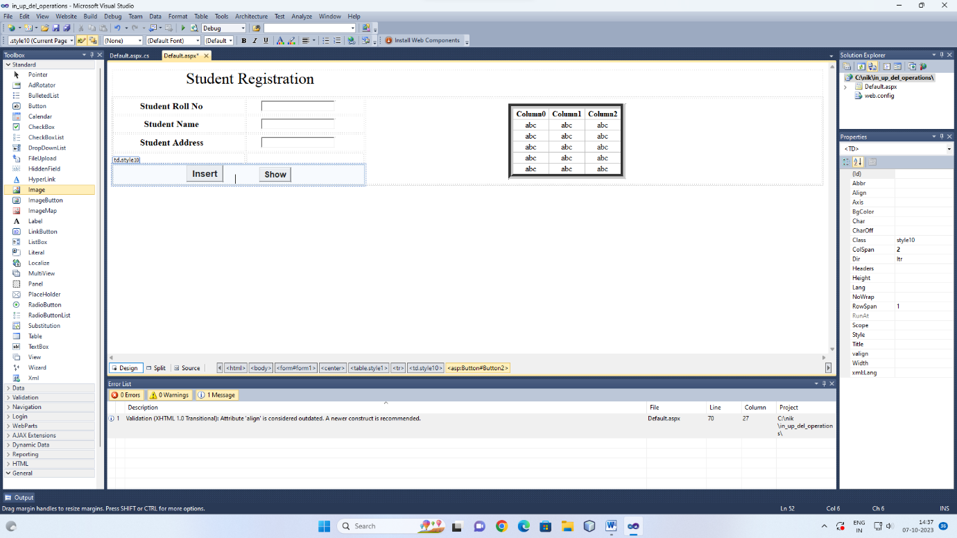

**Button Coding:**

**Insert button:**

protected void Button1_Click(object sender, EventArgs e)

{

OleDbConnection con = new OleDbConnection("Provider=Microsoft.ACE.OLEDB.12.0;Data Source=C:\\nik\\database\\in_up_del_operation.accdb");

OleDbCommand cmd = new OleDbCommand("insert into stud(rollno,sname,sadd) values("+TextBox1.Text+",'"+TextBox2.Text+"','"+TextBox3.Text+"')",con);

con.Open();

cmd.ExecuteNonQuery();

con.Close();

Response.Write("insert successfully");

}

**Show button:**

protected void Button4_Click(object sender, EventArgs e)

{

OleDbConnection con = new OleDbConnection("Provider=Microsoft.ACE.OLEDB.12.0;Data Source=C:\\nik\\database\\in_up_del_operation.accdb");

OleDbCommand cmd = new OleDbCommand("select * from stud",con);

con.Open();

OleDbDataReader dr = cmd.ExecuteReader();

GridView1.DataSource = dr;

GridView1.DataBind();

con.Close();

}

**Assignment No.18:**

Write an ASP.Net Program to Demonstrate Insert , Delete and Display Operations with Microsoft Access Database.

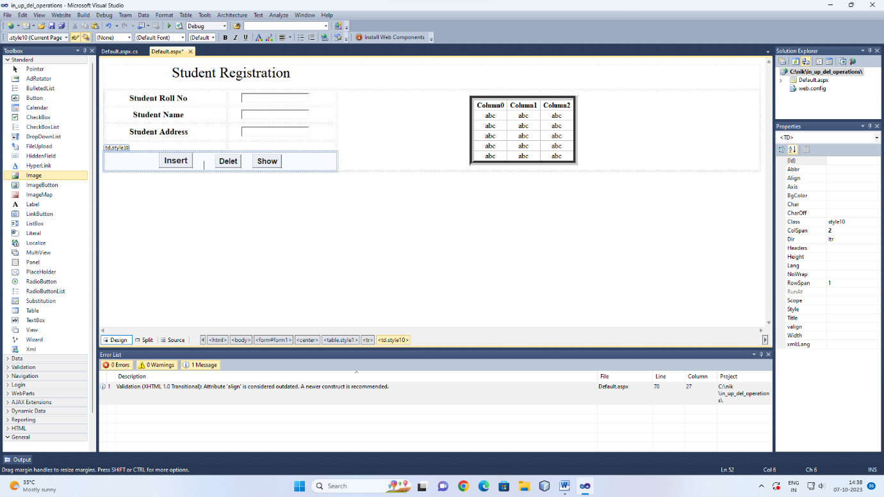

**Button Coding:**

**Insert button:**

protected void Button1_Click(object sender, EventArgs e)

{

OleDbConnection con = new OleDbConnection("Provider=Microsoft.ACE.OLEDB.12.0;Data Source=C:\\nik\\database\\in_up_del_operation.accdb");

OleDbCommand cmd = new OleDbCommand("insert into stud(rollno,sname,sadd) values("+TextBox1.Text+",'"+TextBox2.Text+"','"+TextBox3.Text+"')",con);

con.Open();

cmd.ExecuteNonQuery();

con.Close();

Response.Write("insert successfully");

}

**delete button:**

protected void Button3_Click(object sender, EventArgs e)

{

OleDbConnection con = new OleDbConnection("Provider=Microsoft.ACE.OLEDB.12.0;Data Source=C:\\nik\\database\\in_up_del_operation.accdb");

OleDbCommand cmd = new OleDbCommand("delete from stud where rollno="+TextBox1.Text+"",con);

con.Open();

cmd.ExecuteNonQuery();

con.Close();

Response.Write("delete successfully");

}

**Show button:**

protected void Button4_Click(object sender, EventArgs e)

{

OleDbConnection con = new OleDbConnection("Provider=Microsoft.ACE.OLEDB.12.0;Data Source=C:\\nik\\database\\in_up_del_operation.accdb");

OleDbCommand cmd = new OleDbCommand("select * from stud",con);

con.Open();

OleDbDataReader dr = cmd.ExecuteReader();

GridView1.DataSource = dr;

GridView1.DataBind();

con.Close();

}

**Assignment No.19:**

Write an ASP.Net Program to Demonstrate How We Can Create And Retrive Cookies.

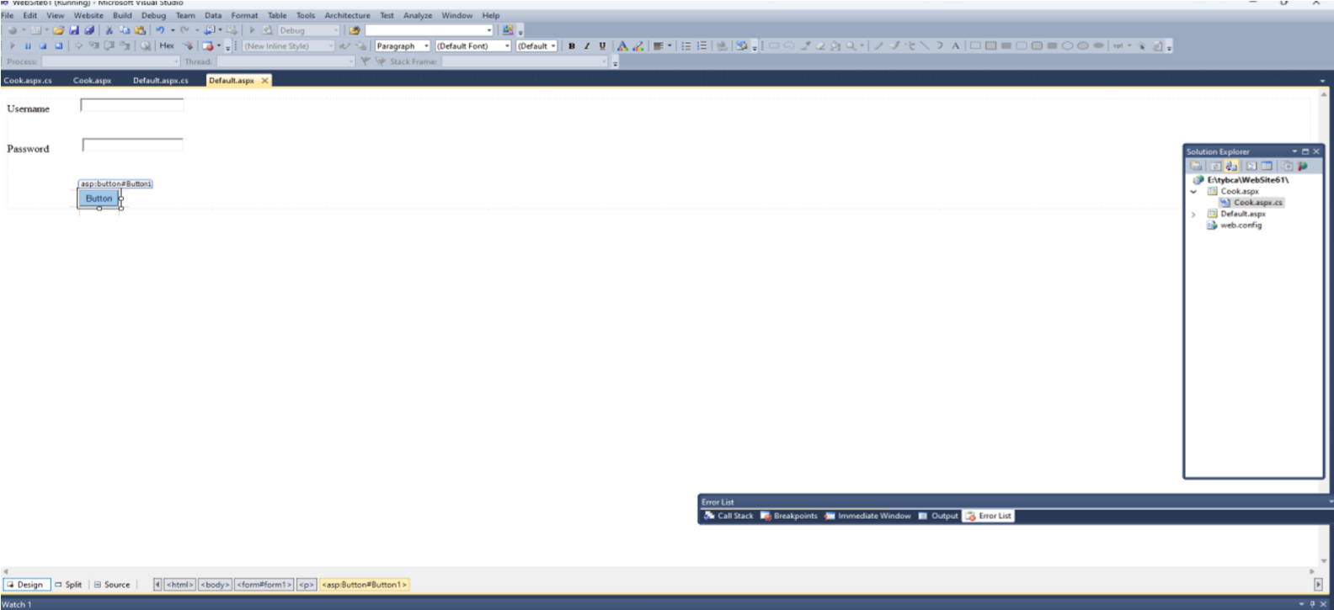

Default.aspx.cs

usingSystem; usingSystem.Collections.Generic; usingSystem.Linq; usingSystem.Web; usingSystem.Web.UI; usingSystem.Web.UI.WebControls;

publicpartialclass_Default:System.Web.UI.Page

{

protectedvoidPage_Load(objectsender,EventArgse)

{

}

protectedvoidButton1_Click(objectsender,EventArgse)

{

Response.Cookies["rcp"].Value=TextBox1.Text;

Response.Cookies["rcp"].Expires.AddDays(1);

Response.Redirect("Cook.aspx");

}

}

Cook.aspx

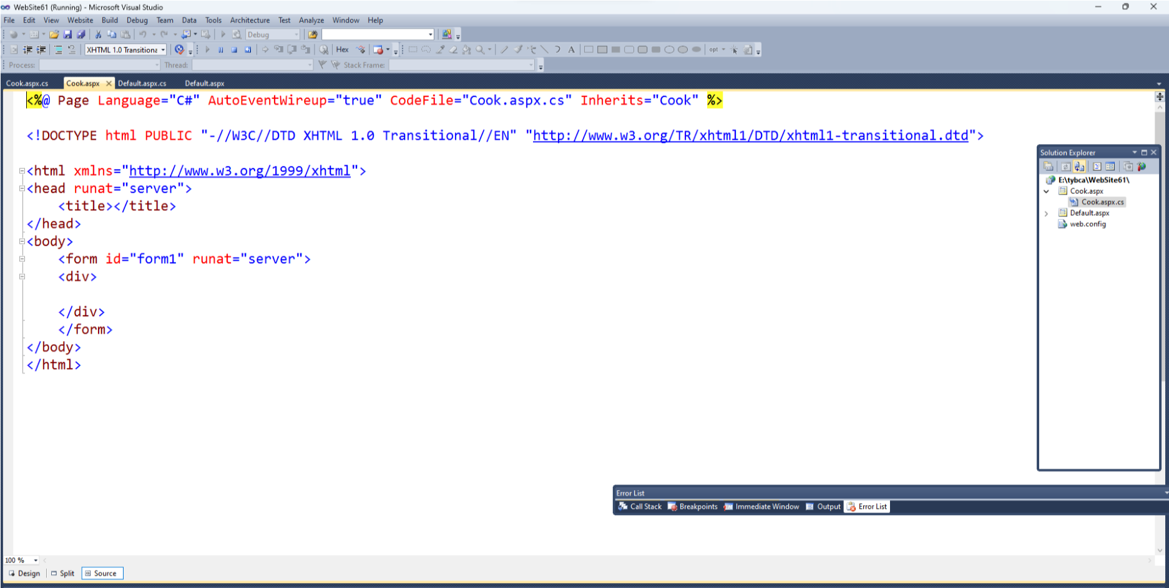

Cook.aspx.cs

usingSystem;

usingSystem.Collections.Generic; usingSystem.Linq; usingSystem.Web; usingSystem.Web.UI; usingSystem.Web.UI.WebControls;

publicpartialclassCook:System.Web.UI.Page

{

protectedvoidPage_Load(objectsender,EventArgse)

{

Response.Write("WelCome"+""+Request.Cookies["rcp"].Value.ToString()+"OnmyWebsite");

}

}

Output:

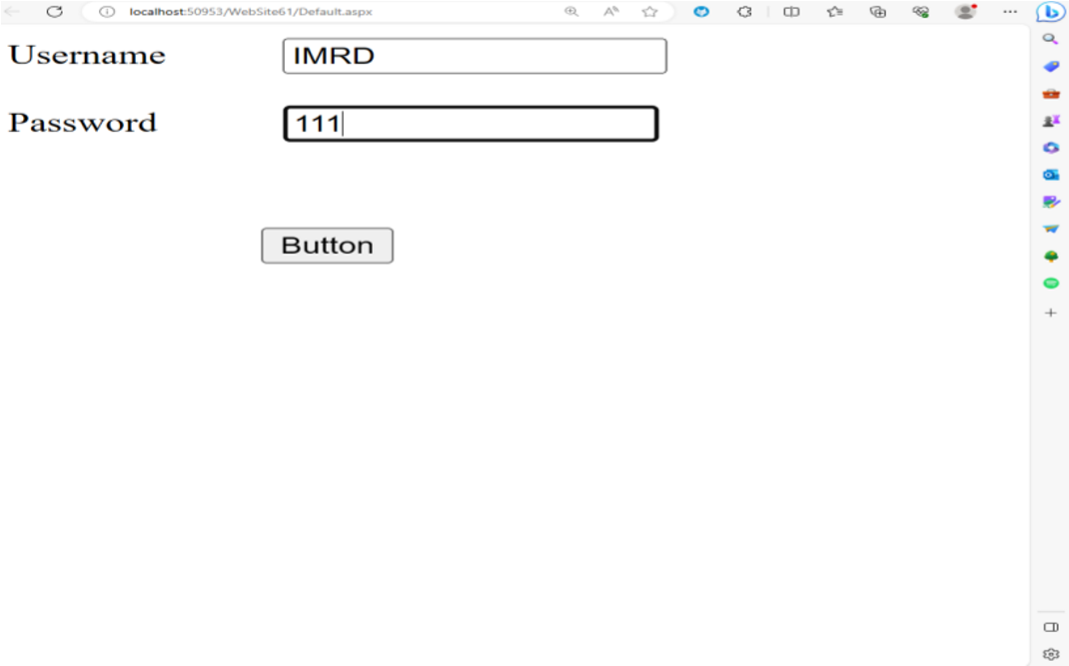

OUTPUT:

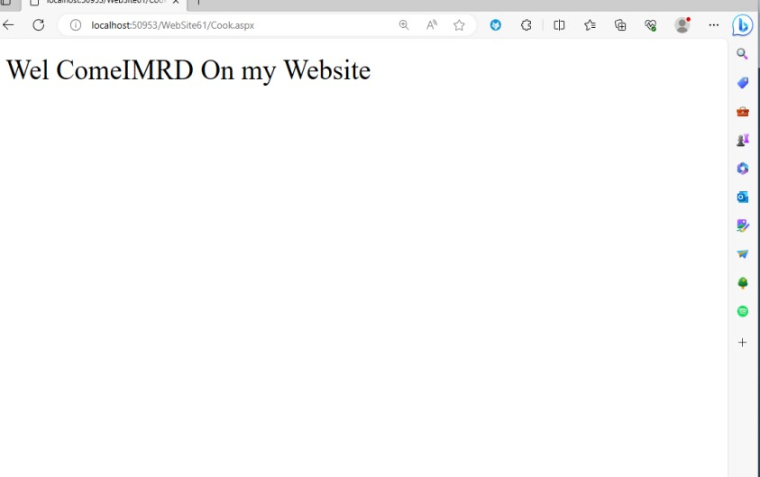

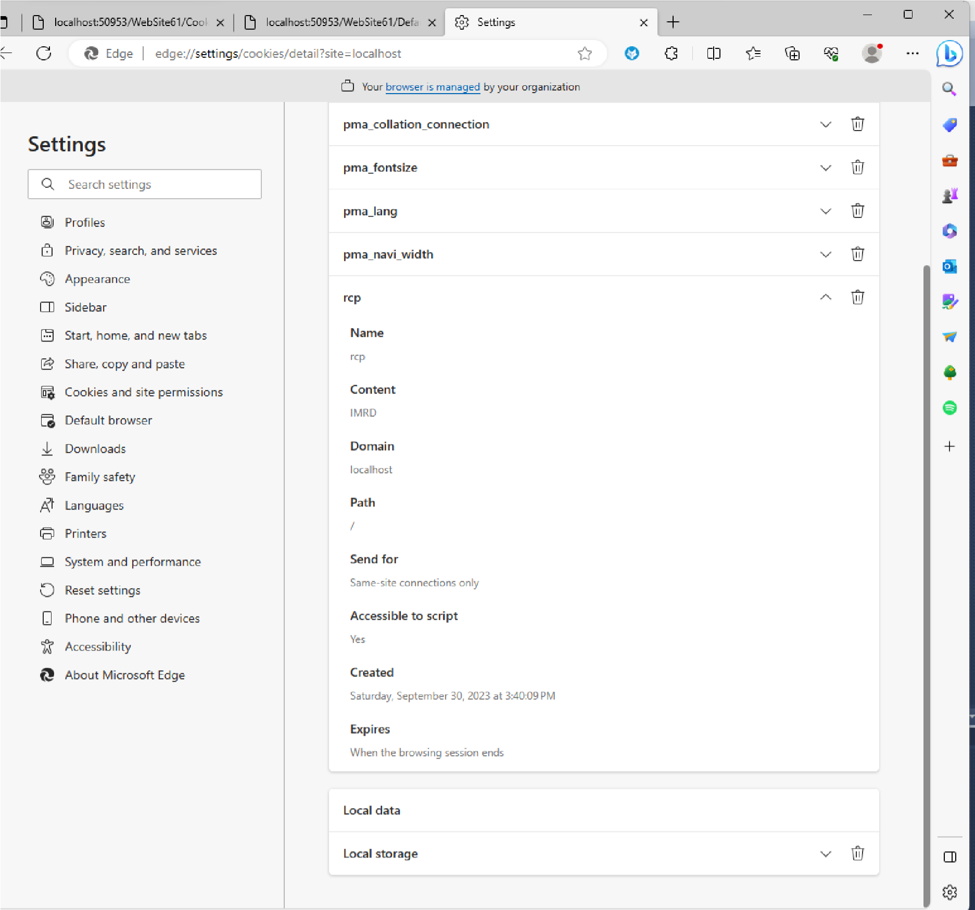

**Assignment No.20:**

Write an ASP.Net Program to Demonstrate Different Database Operation (Select , Insert , Update ,Display and Delete) with Microsoft Access Database.

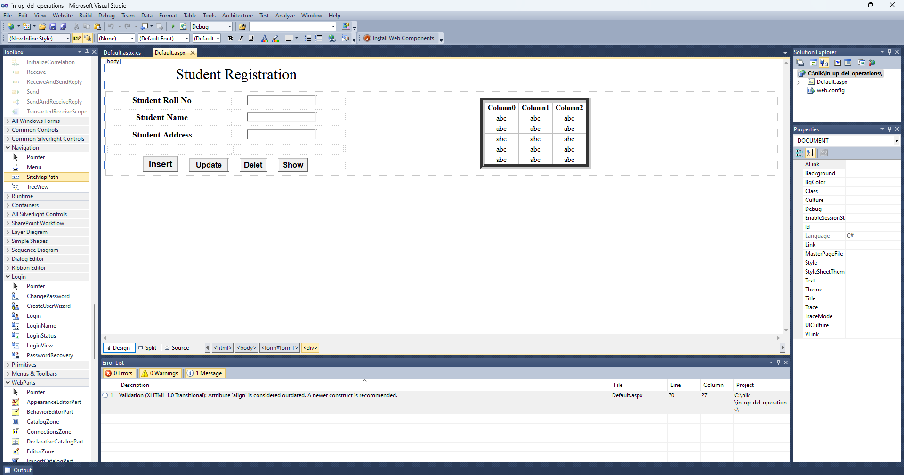

**Button Coding:**

**Insert button:**

protected void Button1_Click(object sender, EventArgs e)

{

OleDbConnection con = new OleDbConnection("Provider=Microsoft.ACE.OLEDB.12.0;Data Source=C:\\nik\\database\\in_up_del_operation.accdb");

OleDbCommand cmd = new OleDbCommand("insert into stud(rollno,sname,sadd) values("+TextBox1.Text+",'"+TextBox2.Text+"','"+TextBox3.Text+"')",con);

con.Open();

cmd.ExecuteNonQuery();

con.Close();

Response.Write("insert successfully");

}

**update button:**

protected void Button2_Click(object sender, EventArgs e)

{

OleDbConnection con = new OleDbConnection("Provider=Microsoft.ACE.OLEDB.12.0;Data Source=C:\\nik\\database\\in_up_del_operation.accdb");

OleDbCommand cmd = new OleDbCommand("update stud set sadd='"+TextBox3.Text+"' where rollno="+TextBox1.Text+"",con);

con.Open();

cmd.ExecuteNonQuery();

con.Close();

Response.Write("update successfully");

}

**delete button:**

protected void Button3_Click(object sender, EventArgs e)

{

OleDbConnection con = new OleDbConnection("Provider=Microsoft.ACE.OLEDB.12.0;Data Source=C:\\nik\\database\\in_up_del_operation.accdb");

OleDbCommand cmd = new OleDbCommand("delete from stud where rollno="+TextBox1.Text+"",con);

con.Open();

cmd.ExecuteNonQuery();

con.Close();

Response.Write("delete successfully");

}

**Show button:**

protected void Button4_Click(object sender, EventArgs e)

{

OleDbConnection con = new OleDbConnection("Provider=Microsoft.ACE.OLEDB.12.0;Data Source=C:\\nik\\database\\in_up_del_operation.accdb");

OleDbCommand cmd = new OleDbCommand("select * from stud",con);

con.Open();

OleDbDataReader dr = cmd.ExecuteReader();

GridView1.DataSource = dr;

GridView1.DataBind();

con.Close();

}

**Assignment No.21:**

**Write an ASP.Net Program Using AdRotator Control.**

Step 1 :- Open Visual Studio 2010.

Step 2 :- Create new Website.

Step 3:- Go to solution explorer > right click > Add new item > xml file.

Step 4:- Write a below code in xml file.

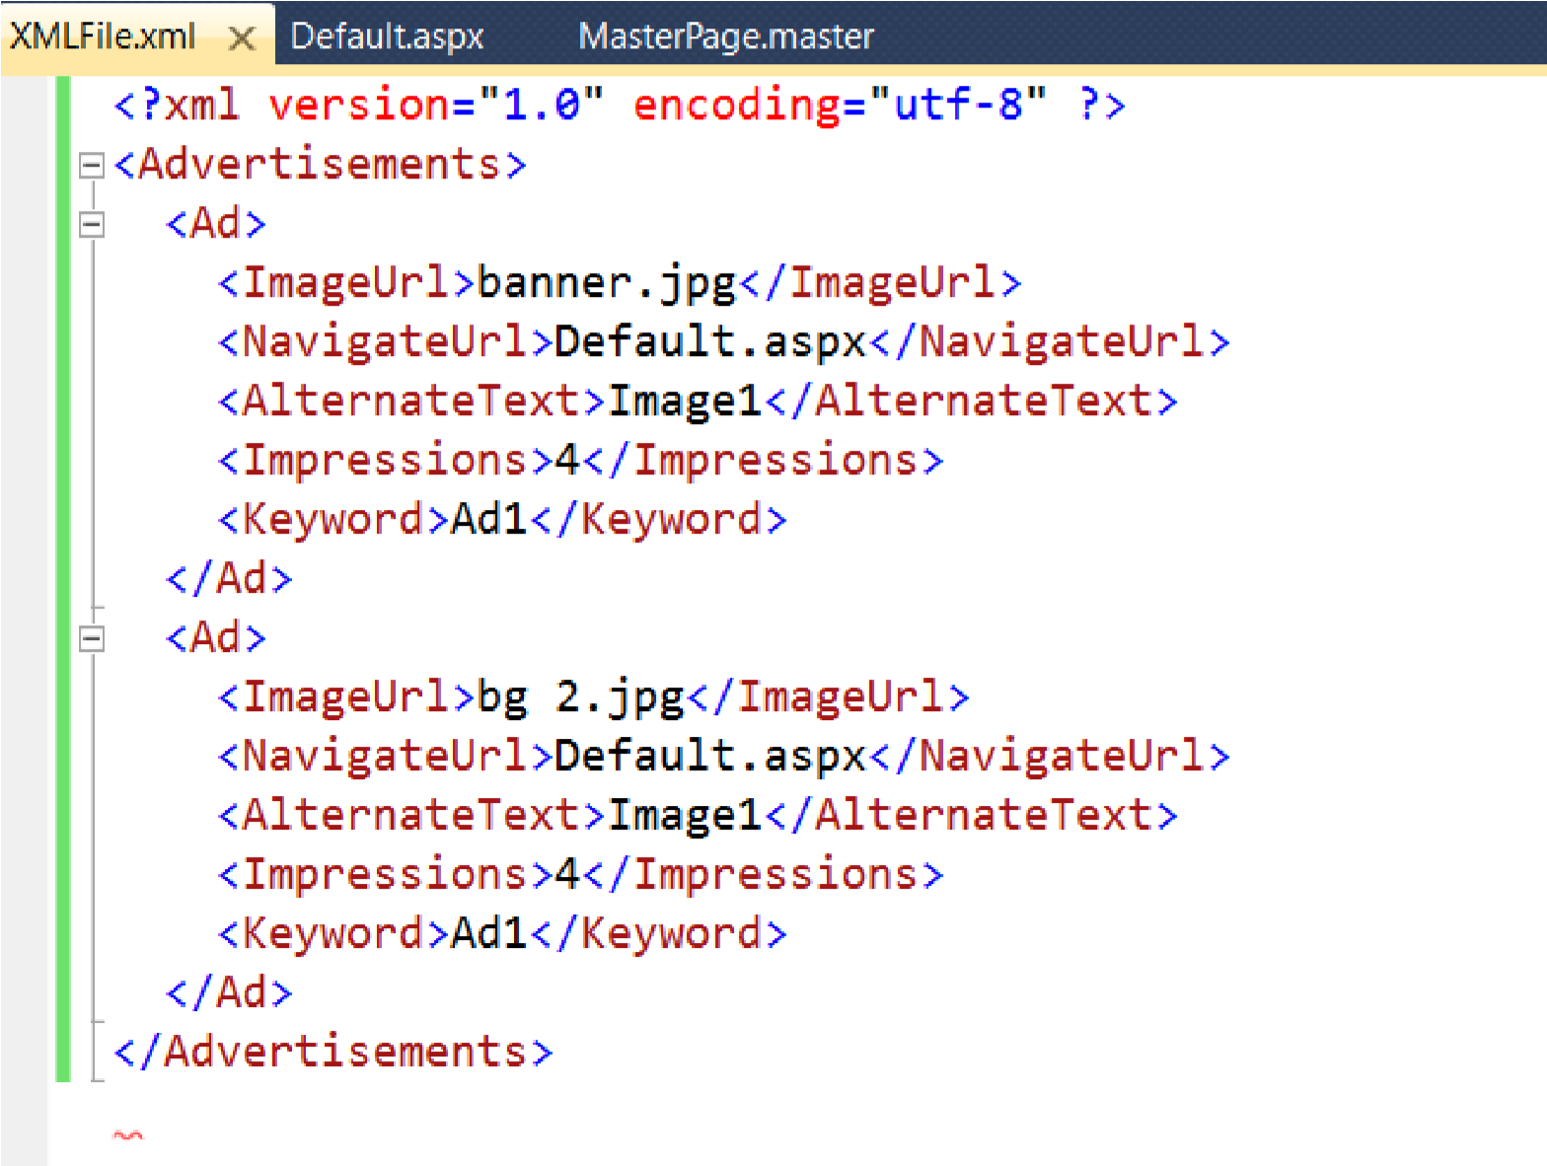

Step 5:- Go to Tool Box and place AdRotator Control on form.

Step 6:- Go to properties and select AdvertisementFile property and pass xml file Url.

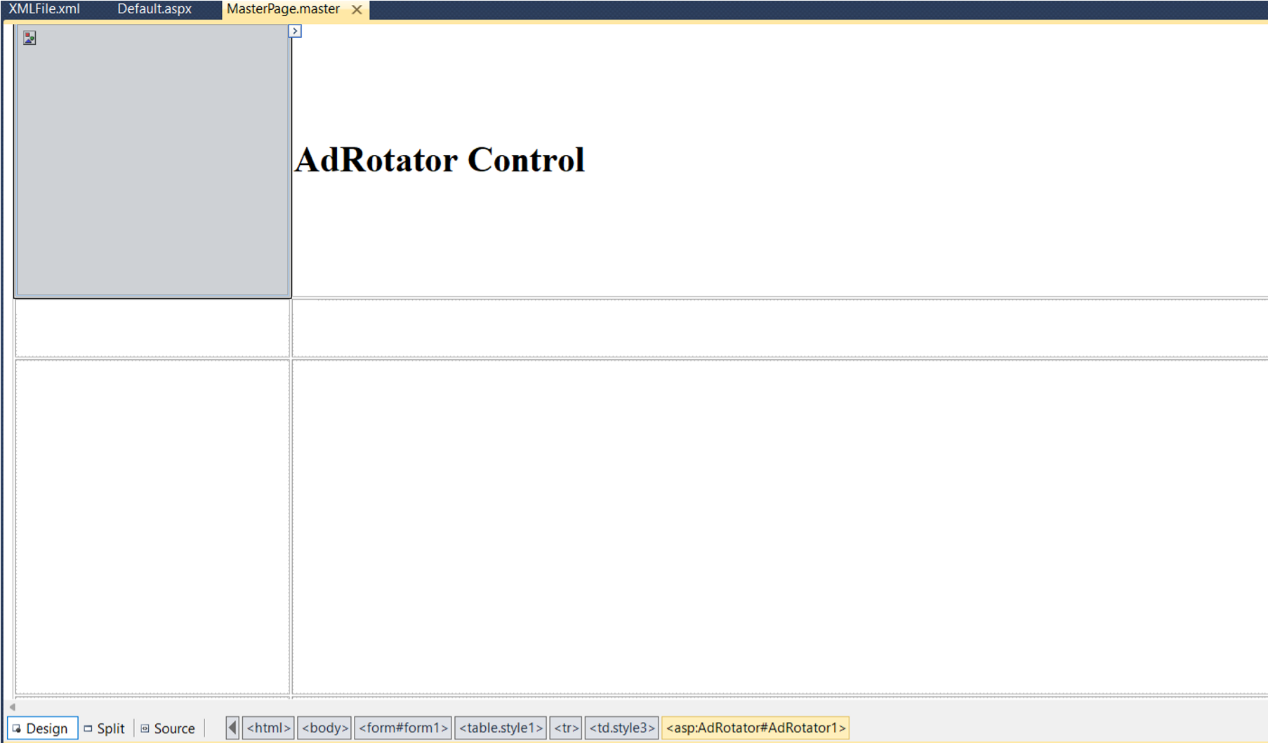

Step 7:- Run program.

